

# Tablist Of Content

**Ecommerce Website 1**

**Index 2**

**I.** **Project introduction 3**

**II.** **Analyze System Requirements 3**

**III.** **Design Details 8**

**IV.** **Test 14**

**V.** **Task Assign (to each team member) 15**

**VI.** **Installation Instructions 16**

**Appendix 17**

**Document format 18**

# Project introduction

1. Proposed System

* Create a Sales Website
* Expand your ability to interact with customers
* Get feedback from customers more convenient

1. The scope of the project to be applied

* Run on Internet

1. System Name

* ECommerce Website for fashion store

1. Deployment Environment

* Internet

1. Development Tools

* Visual Studio Code
* Microsoft Visual Studio
* Microsoft SQL Server Management Studio 2018
* AdobeXD
* Ubuntu 20.04 LTS
* Microsoft DevTool
* Windows PowerShell

1. Customer Requirements

* Customer want to have a good Ul design
* Customer want to have a good Seo website
* Customer want to show list product (sort, search)
* Customer want to classify the products (one product will belong to one or multiple categories)
* Customer want to make multiple-levels for product categories
* Customer want to sell online on website
* Customer want to manager easy all products
* Customer want to have members
* Customer want to control access from admin
* Customer want to integrate payment online
* Customer want to integrate login with Google and Facebook
* Customers want to show product details (unique code,name,description, price warranty...)
* Do Customers want to have a promotion? Sales?
* Customer want to have multiple-images for each product
* Customer want to have contact information

1. Analyze System Requirements

| 1. Landing Page 2. Online shopping eCommerce System    1. Account Management (Register,Login,External Login,solution for password,...)    2. User Management ( Personal information, Notification management , Order checking)    3. Market Place (Show products and menus )    4. (Optional) Payment System    5. Order Management (order and checkout only)    6. (Optional)Website Only 3. Internal Operation System    1. Order Management (Update order status    2. Categories and Products Management    3. (Optional) Reporting website |
| --- |

# Analyze System Requirements

1. Overall system use case

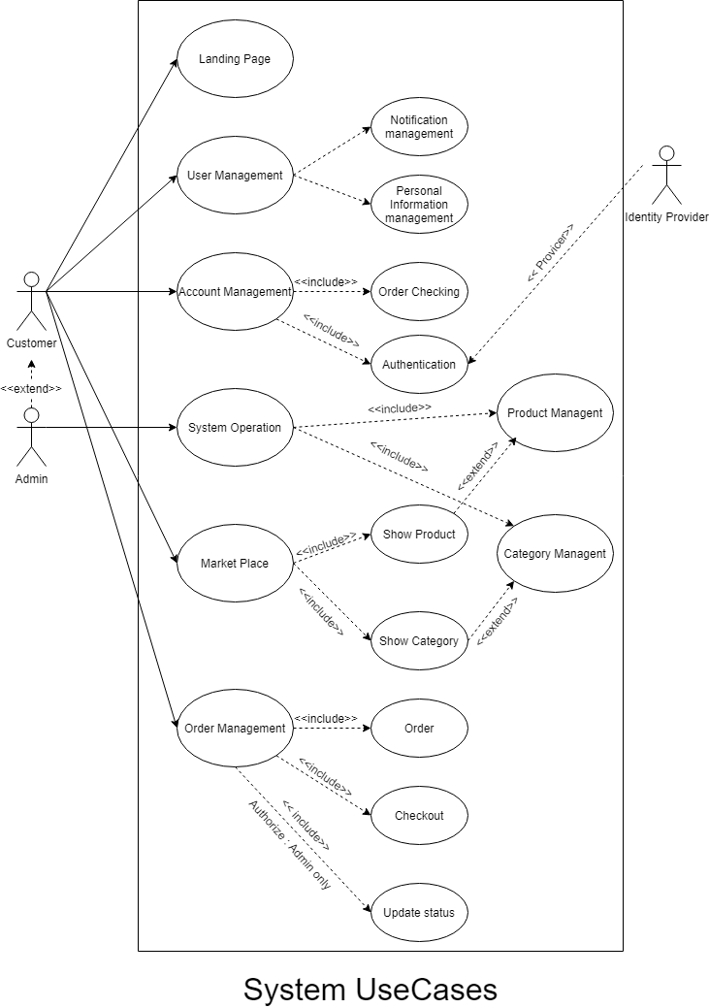

* 1. Overall customer use case

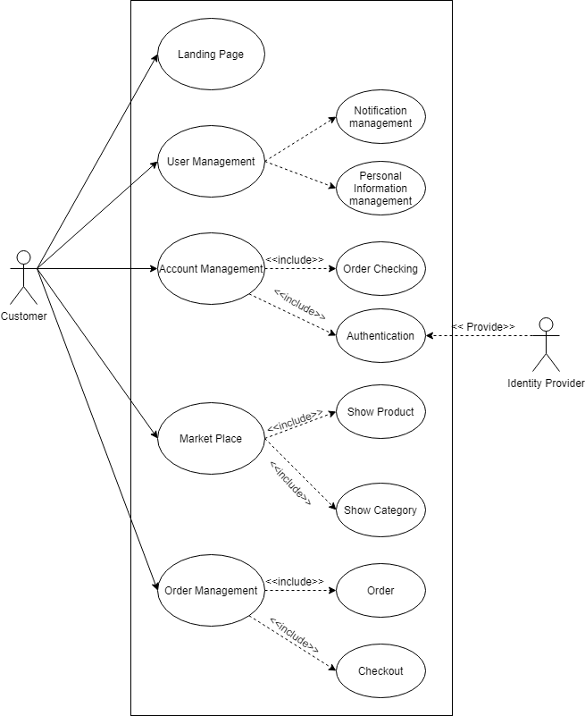

1.2 Overall admin use case

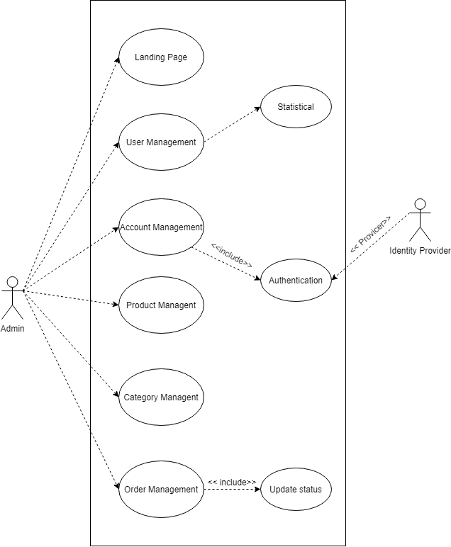

2. Description

1. Online Shopping eCommerce System

2.1 Create order

| Name | Create order |
| --- | --- |
| ID |  |
| Description | create orders to help customers buy the products which they want |
| Actor | customer |
| Organizational Benefits | users can order and take initiative in order time |
| Frequency of Use | sometime |
| Triggers | the user chooses the product and places an order |
| Preconditions | You already have products in your shopping cart, the user must be the customer |
| Postconditions | Users can continue to buy, cancel the order |
| Main Course | 1. Login 2. Access to website   3.  view product AC1  4.  Show Items List  5.  Browse Item  6.  View Item Detail AC2  7.  Add to shopping cart AC3  8.  View Shopping cart AC4  9.  Confirm Item Price/Qnt      10.  Confirm Personal Information      11.  Confirm Shipping and Payment Method      12.  Checkout |
| Alternate Courses | AC1.1 Browse   1. Return main count step 4   AC1.2 Search   1. Search Item    1. Found  * Return main count step 4  1. Not found  * Return main count step 2   AC2. Ignore item   1. Continue Browse  * Return main count step 3  1. Continue Searching  * Return manin count step 3   AC3.1 Continue shopping   * Return main count step 2   AC3.2 View cart   * Return manin count step 8   AC4.1 Continue Shopping   * Return main count step 2   AC4.2 Done with shopping   * Return main count step 9 |
| Exceptions | EX1: User hasn’t logged in yet   * Redirect to LoginPage   EX2: User doesn’t have active address page   * Redirect to Create new address card page |

2.2 User Management

a. Login

| Name | Login |
| --- | --- |
| ID | UC01 |
| Description | Allow users to log into the system |
| Actor | Customer, admin, stuff |
| Organizational Benefits | Authentication |
| Frequency of Use | Often |
| Triggers | Follow login journey |
| Preconditions | Has account on system |
| Postconditions | Return to home page |
| Main Course | 1. Input Username and password AC1 2. Login request accepted Ac2 3. Checking Account has confirm email AC3 4. User Login success |
| Alternate Courses | AC1.1 Input Invalid   1. Display error  * Return main count step 1   AC1.2 Cannot find account   1. Display error  * Return main count step 1   AC2 The account has been lockout   1. Display error  * Return main count step 1   AC3 Notify to user to Confirm email   1. User Login success |
| Exceptions | EX1. Valid Username:  - None special characters  - Maximum 20 characters  EX2.  2.1Valid Password  - Minimum password length 8 characters  - Minimum 1 uppercase character  - Minimum 1 normal character  - Minimum 1 numeric character  2.2 Username Password fails  - Return user to Main Course Step 1 |

b. Register

| Name | Register |
| --- | --- |
| ID |  |
| Description | Allows users to register for an account |
| Actor | User |
| Organizational Benefits | Users create accounts |
| Frequency of Use | usually |
| Triggers | Click register button |
| Preconditions | must have email or phone number |
| Postconditions | Continues using more function |
| Main Course | 1. Input email Ac1 2. User click follow link on email Ac2 3. Input new password Ac3 4. Change password 5. login |
| Alternate Courses | Ac1.1 not found   1. display error  * return main count step1   Ac1.2 password reset token generation   1. display error  * return main count step1   Ac1.3 token encryption   1. display error  * return main count step1   AC1.4 attach token with callback url link to   1. display error  * return main count step1   Ac1.5 send mail   1. display error  * return main count step1   Ac2 redirected by callback url   1. Cannot read token  * return main count step 5   Ac3 Input invalid   1. display error  * return main count step 3 |
| Exceptions | * Invalid email * invalid phone number |

2.3. Account Management

| Name | Account Management |
| --- | --- |
| ID |  |
| Description | -Users can update account information such as personal information, email, password, account name, address in the respective navigation bars.  -User can check the notification inbox in the “notification” navigation bar  -User can check invoice status in “ your invoice “ navigation bar |
| Actor | Customer |
| Organizational Benefits | Manage all information related to user accounts |
| Frequency of Use | Often |
| Triggers |  |
| Preconditions | Logged |
| Postconditions | Manage Account information |
| Main Course | 1.Click into Account Navigation  2. Click into navigation (AC2) |
| Alternate Courses | AC2: Navigation   1. Updates personal information navigation bar    1. Update Name    2. Update Phone Number    3. Update Birthday 2. Update email/Password navigation bar    1. Update email       1. Confirm new Email    2. Update Password       1. Enter new password       2. Confirm new password 3. Order Management navigation bar    1. Checking process of order    2. Cancel Order 4. Notification navigation bar    1. Checking notification from website    2. Delete Notification    3. Mark as read |
| Exception | EX2:   1. Name,Phone Number,Birthday invalid 2. User doesn’t confirm new email 3. New password invalid 4. cannot cancel order |

B. Internal Operation System

2.4 Order Management

| Name | Manage Order |
| --- | --- |
| ID |  |
| Description | Order management refers to the process of receiving, tracking, and fulfilling customer orders. The order management process begins when an order is placed, and ends when the customer receives their package |
| Actor | Customer, admin, staff |
| Organizational Benefits | Help staff compose orders, track the progress of implementing orders for goods and products, plan to carry out packaging and delivery work according to orders |
| Frequency of Use | often |
| Triggers |  |
| Preconditions | the user has placed an order |
| Postconditions | the customer can cancel the order and continue to purchase |
| Main Course | 1. Receive Order 2. Check stock AC1 3. Order accepted 4. Delivery 5. Payment confirmation 6. Close order |
| Alternate Courses | AC1.1 Stock not enough   * Notify to user to out of stock * Close order   Ac1.2 Order rejected   * Notify to customer * Close order |
| Exceptions | Ex1:   1. Unable to retrieve order data 2. Backup status |

2.5 Category and product management

| Name | Category and product Management |
| --- | --- |
| ID |  |
| Description | Users can update information of product catalogs and products |
| Actor | Staff, admin |
| Organizational Benefits | Flexibly change the object's information, create new and update easily |
| Frequency of Use | Often |
| Triggers |  |
| Preconditions | Have account with “staff” role |
| Postconditions |  |
| Main Course | 1. Select page in dashboard navigation bar (AC1) 2. Select the category/product to perform the operation 3. Execute update information 4. Submit |
| Alternate Courses | AC 1: With Category   1. On Create:   1.1: Click on create new button  1.2: Fill category information  1.3: Submit   1. On Update:   1.1: Select category which want to update  1.2: Fill update information  1.3: Submit  AC 1.2: With Product   1. On Create:   1.1: Click on create new button  1.2: Fill product information  1.3: Submit   1. On Update:   1.1: Select product which want to update  1.2: Fill update information  1.3: Submit |
| Exceptions | EX1:   1. New category information invalid 2. internal server error   EX2:   1. New Product information invalid 2. internal server error |

1. Activity Diagram

3.1 Create Order Activity Diagram

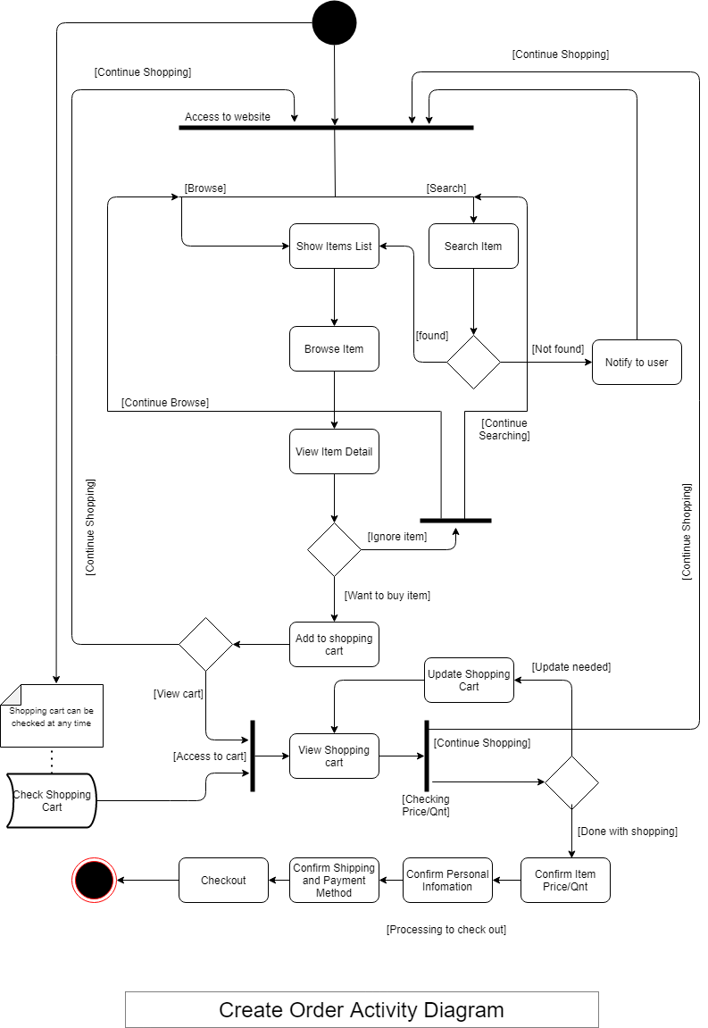

3.2 User Management

1. Login Activity Diagram

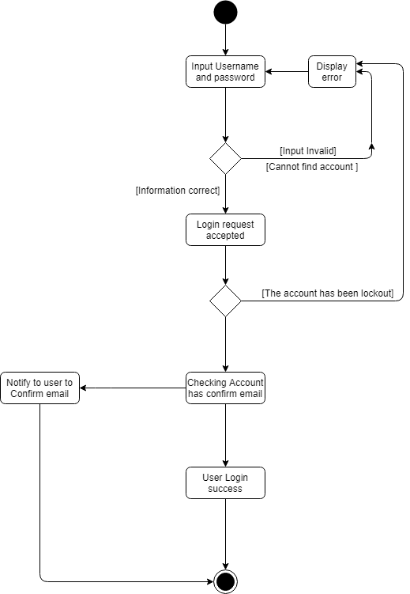

1. Register

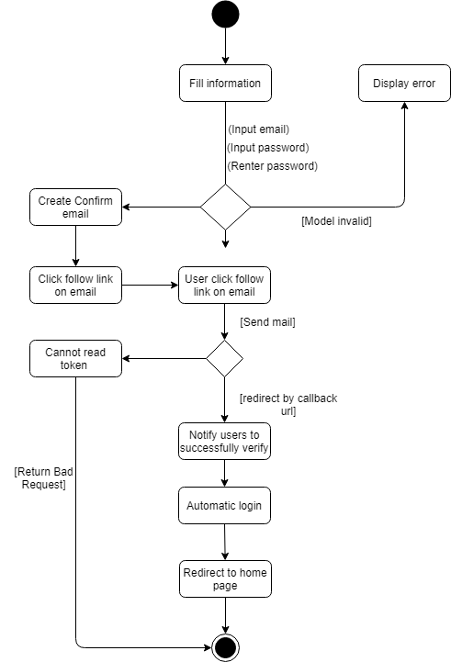

3.3 Account Management

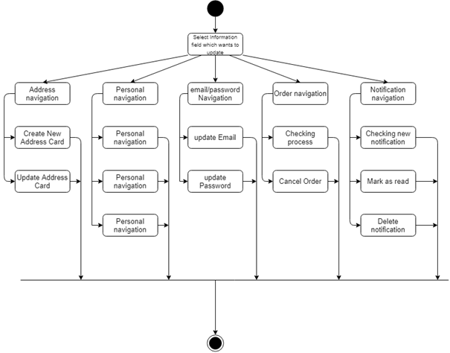

3.4 Order Management

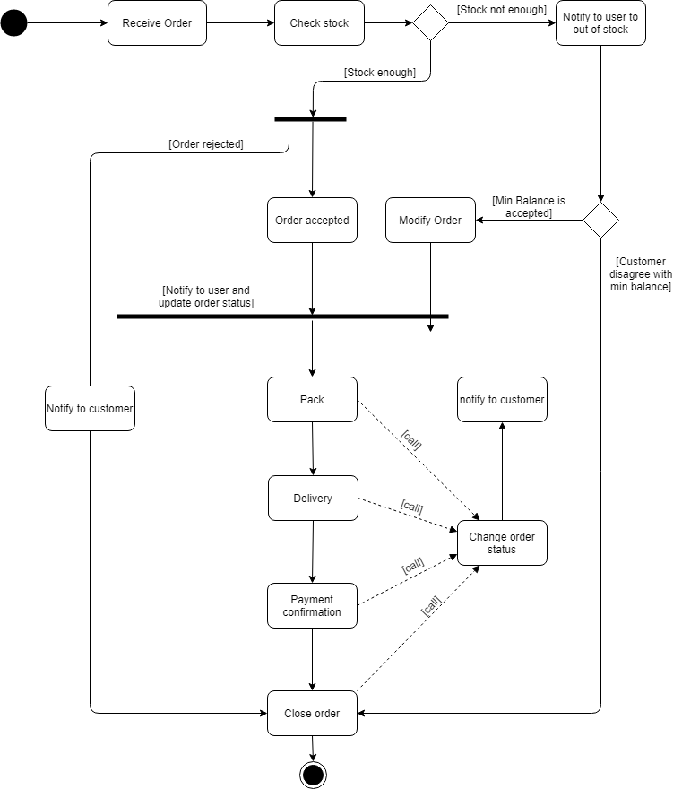

3.5 Category and product Management

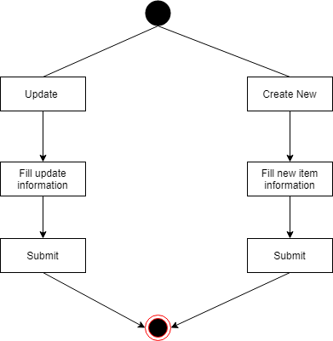

4. Sequence Diagram

4.1 Create Order

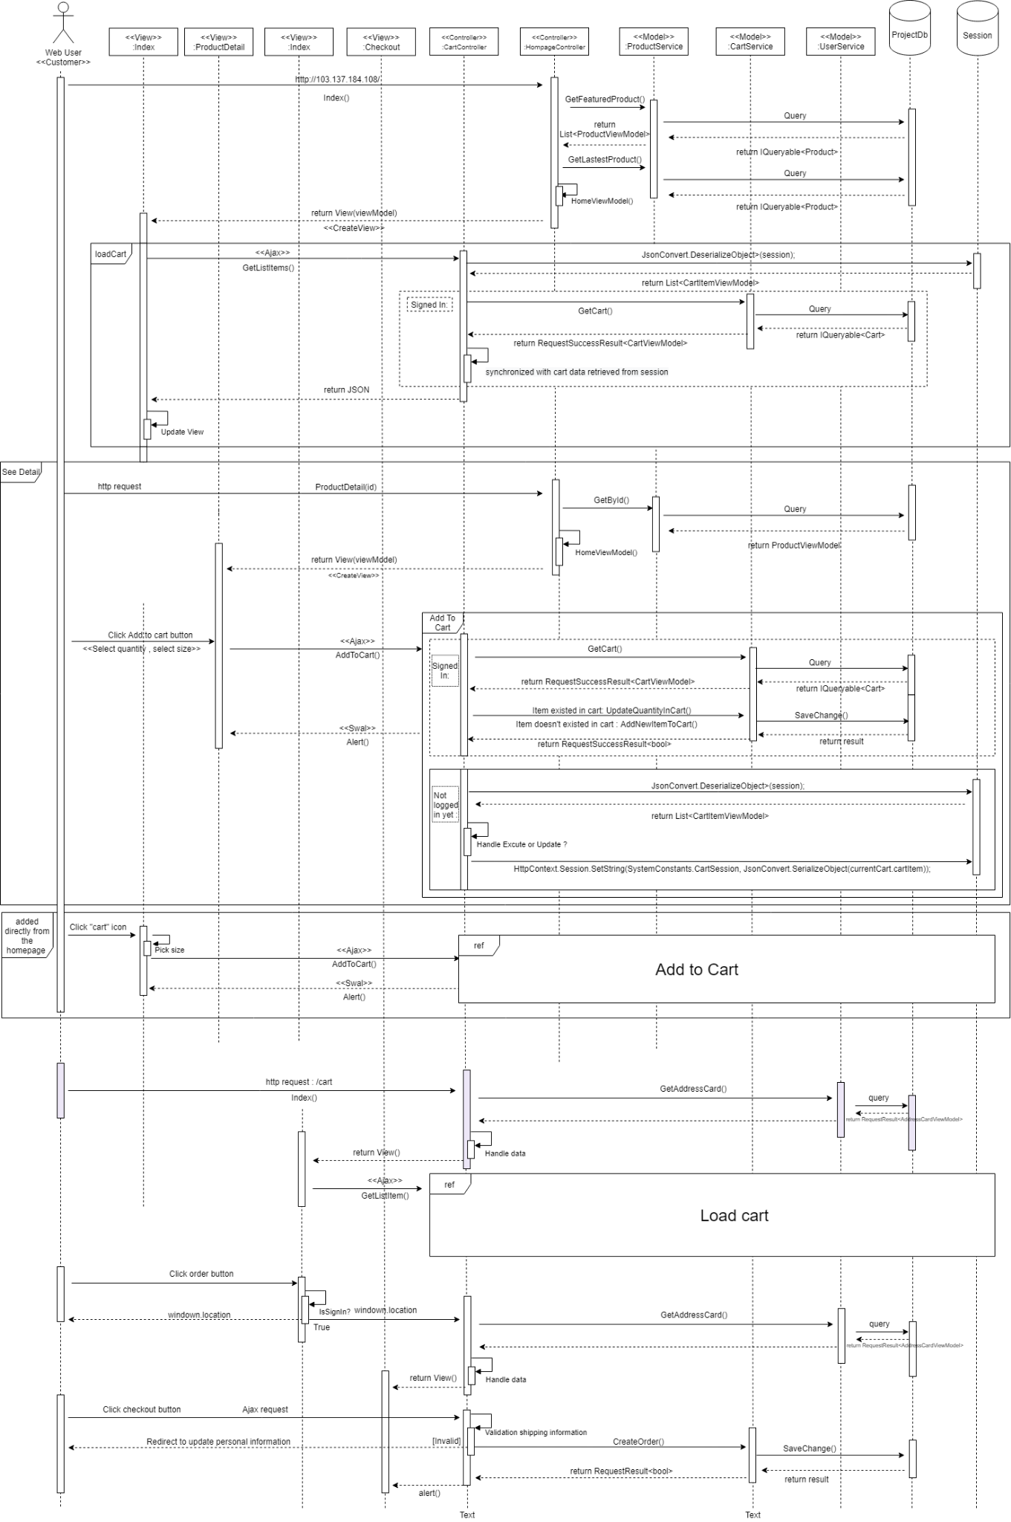

4.2 User Management

1. Login

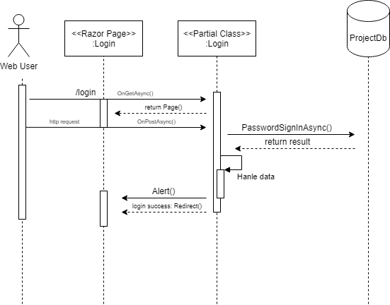

b.Register

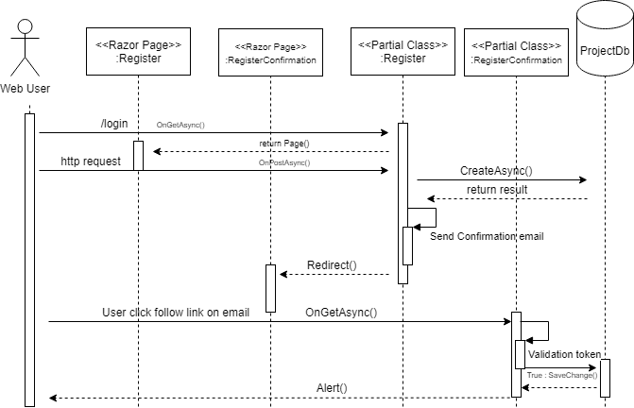

4.3 Account Management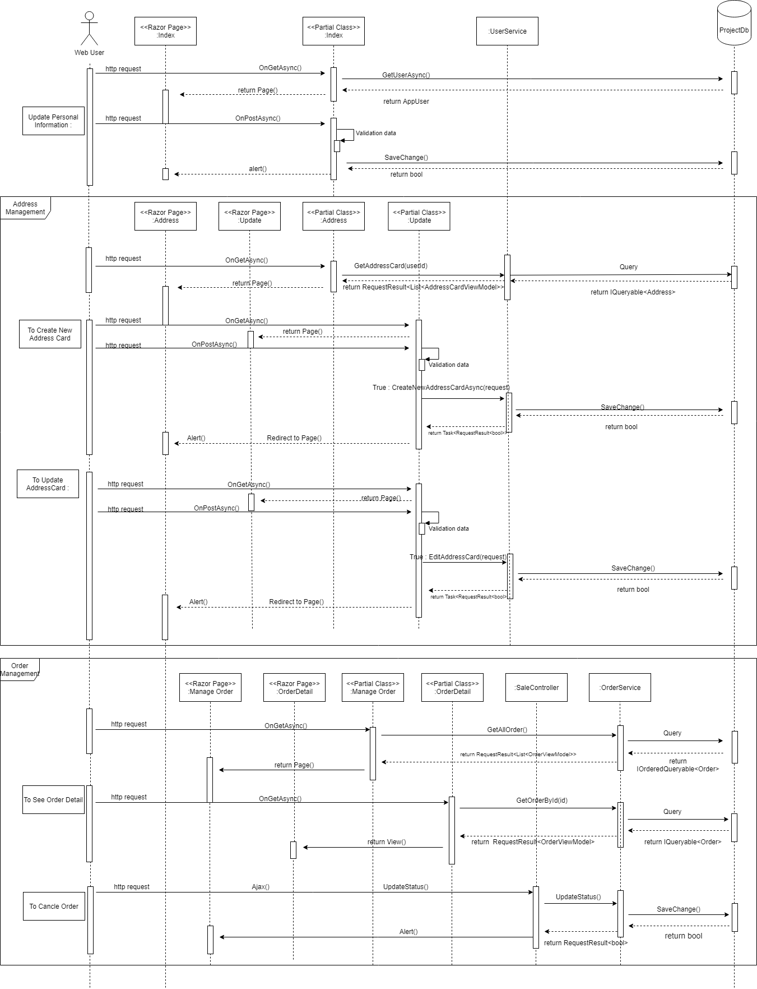

4.4 Order Management

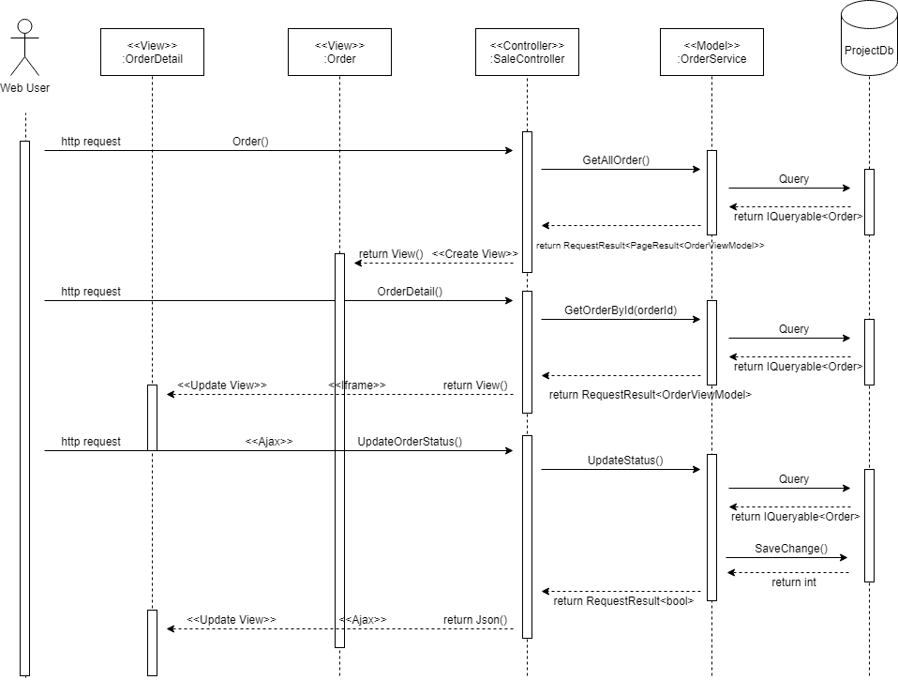

4.5 Category and product management

1. Category

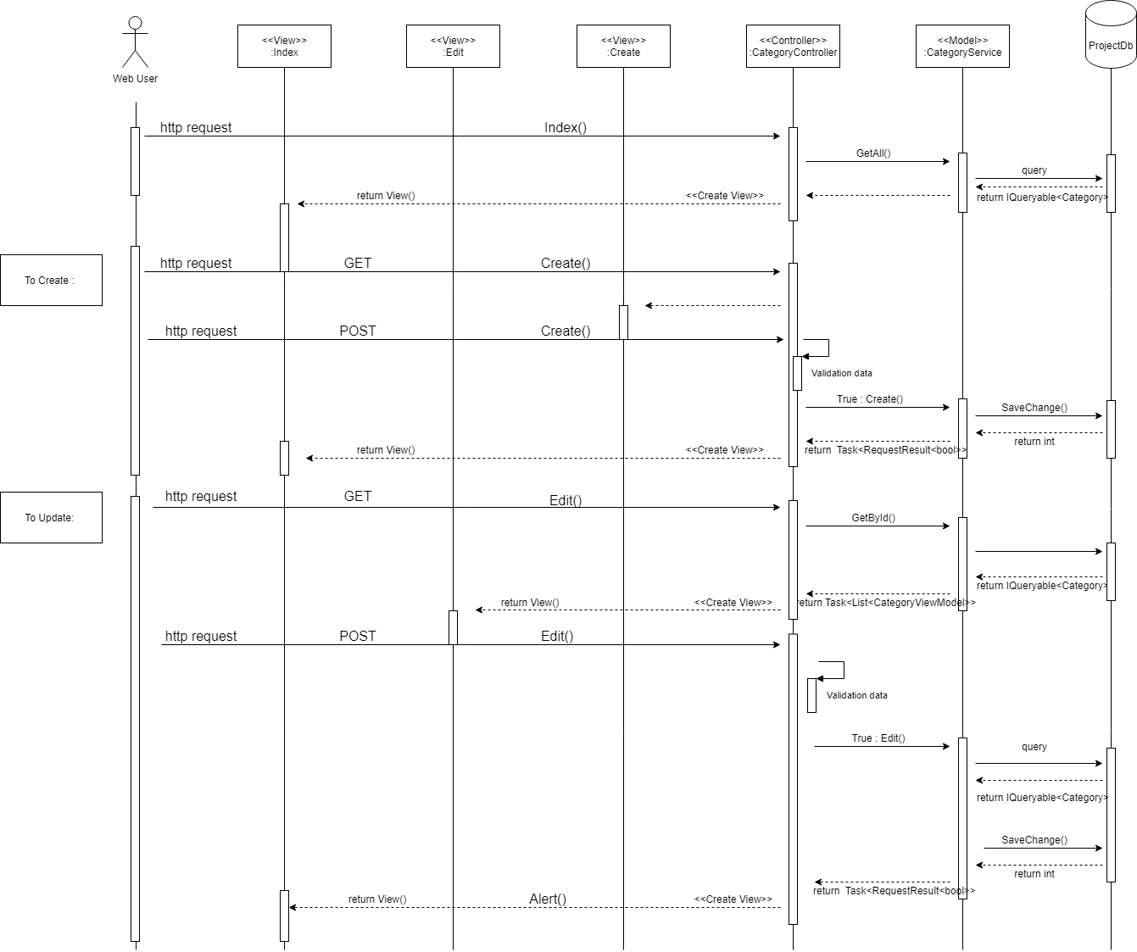

1. Product

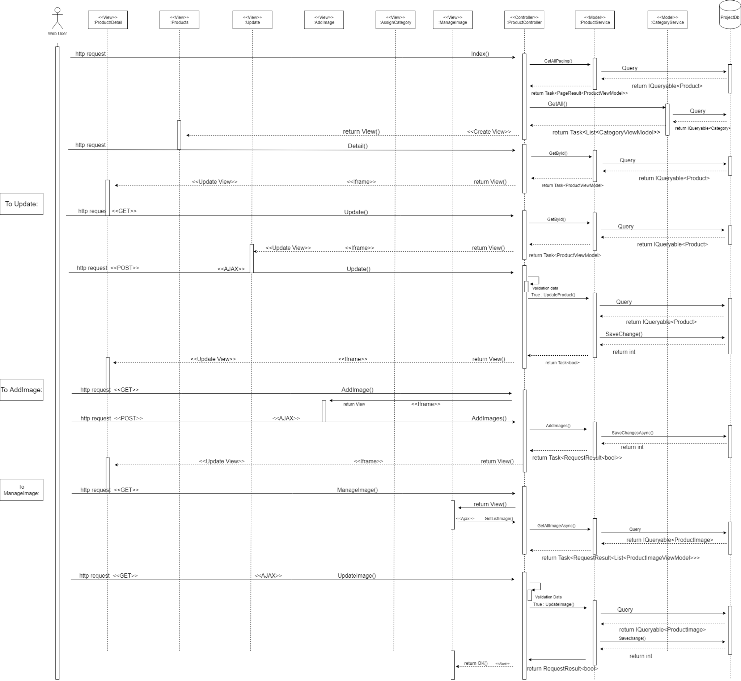

# Design Details

1. UI Design
2. Client Side

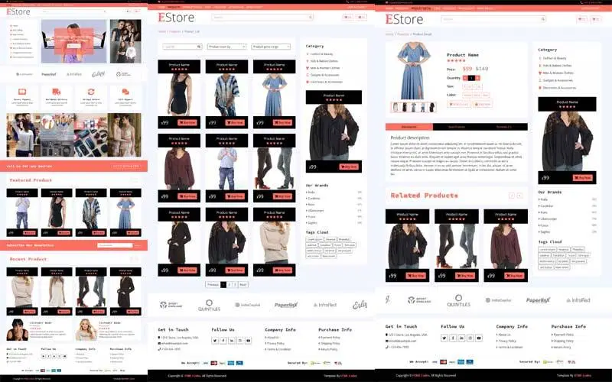

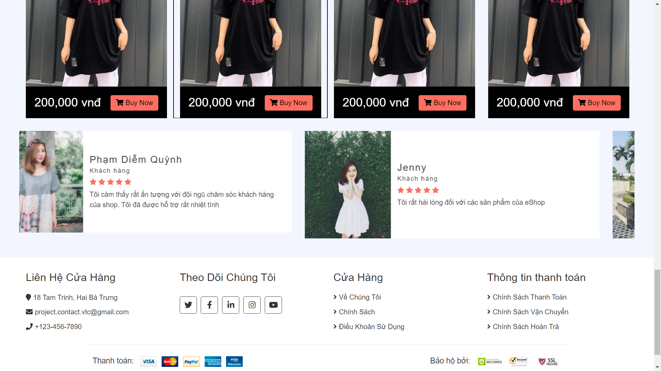

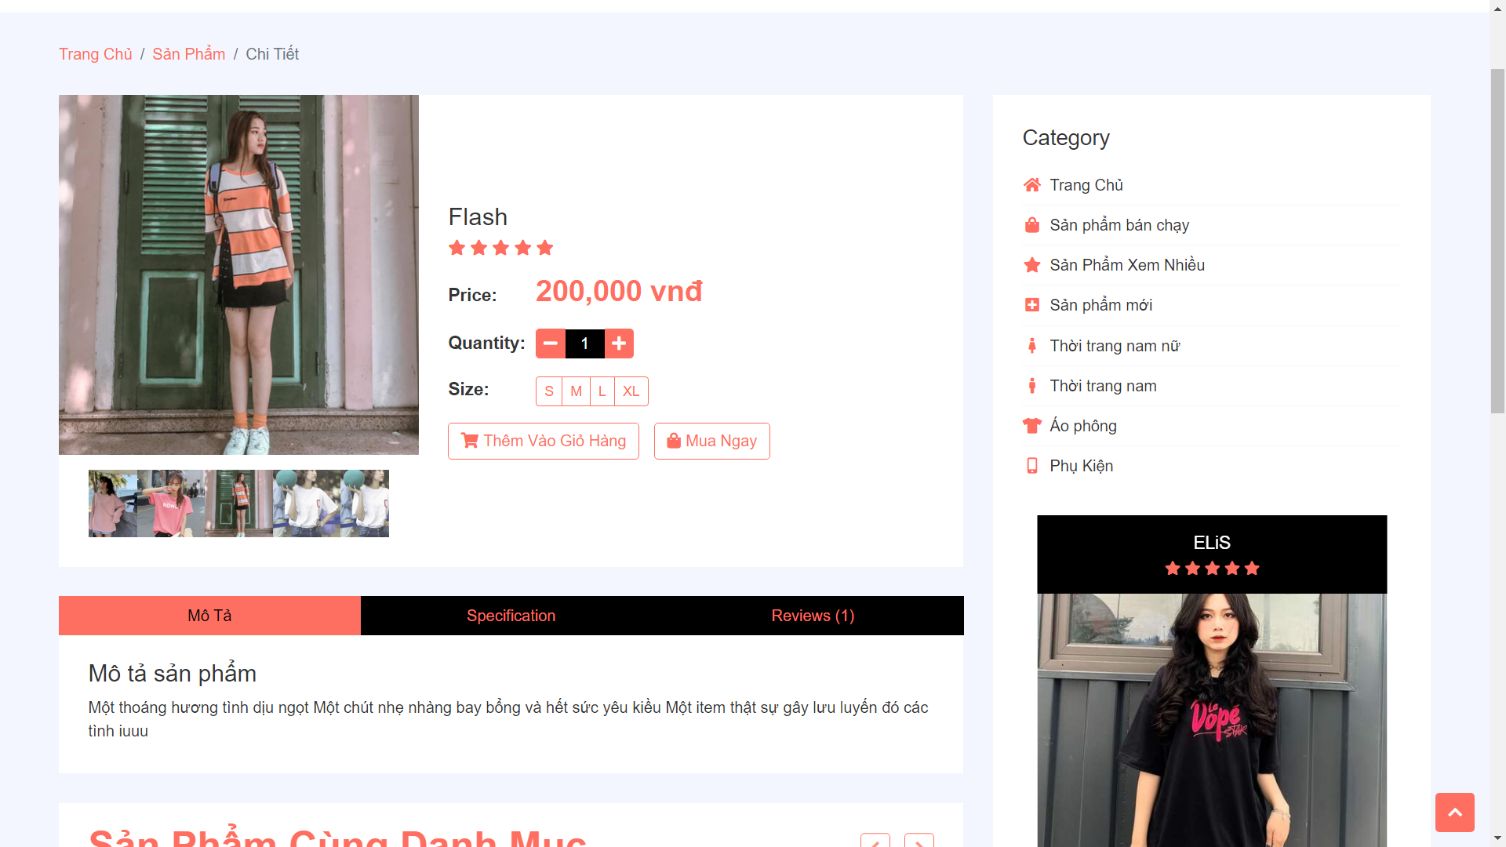

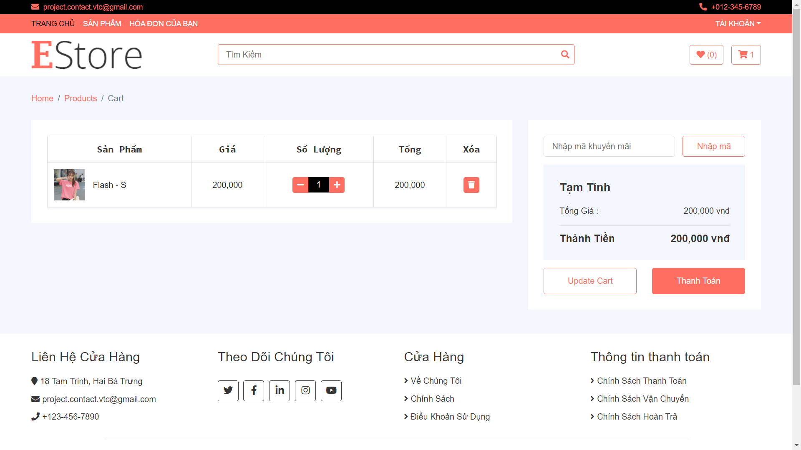

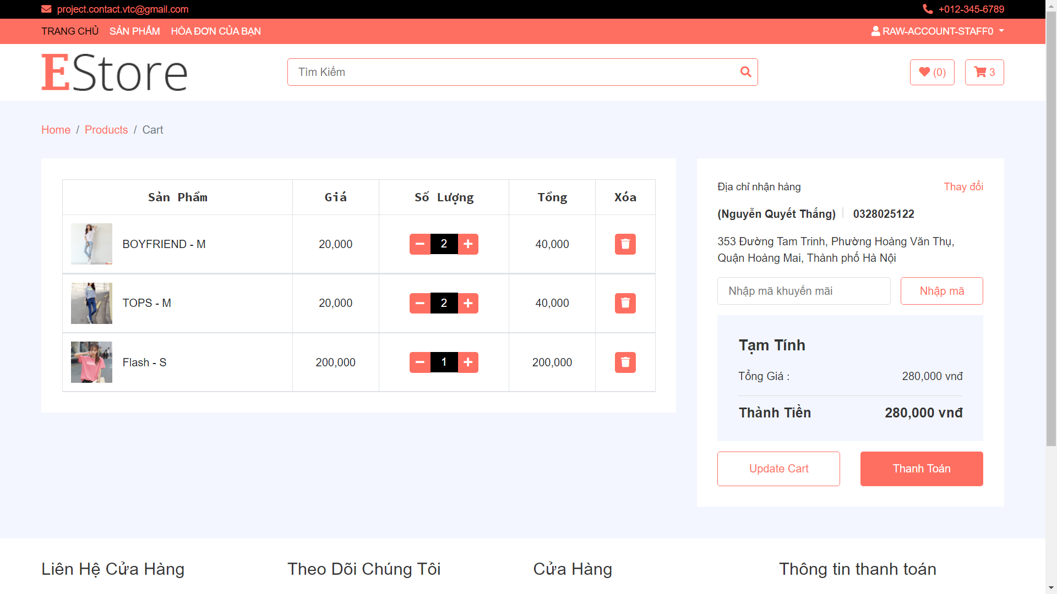

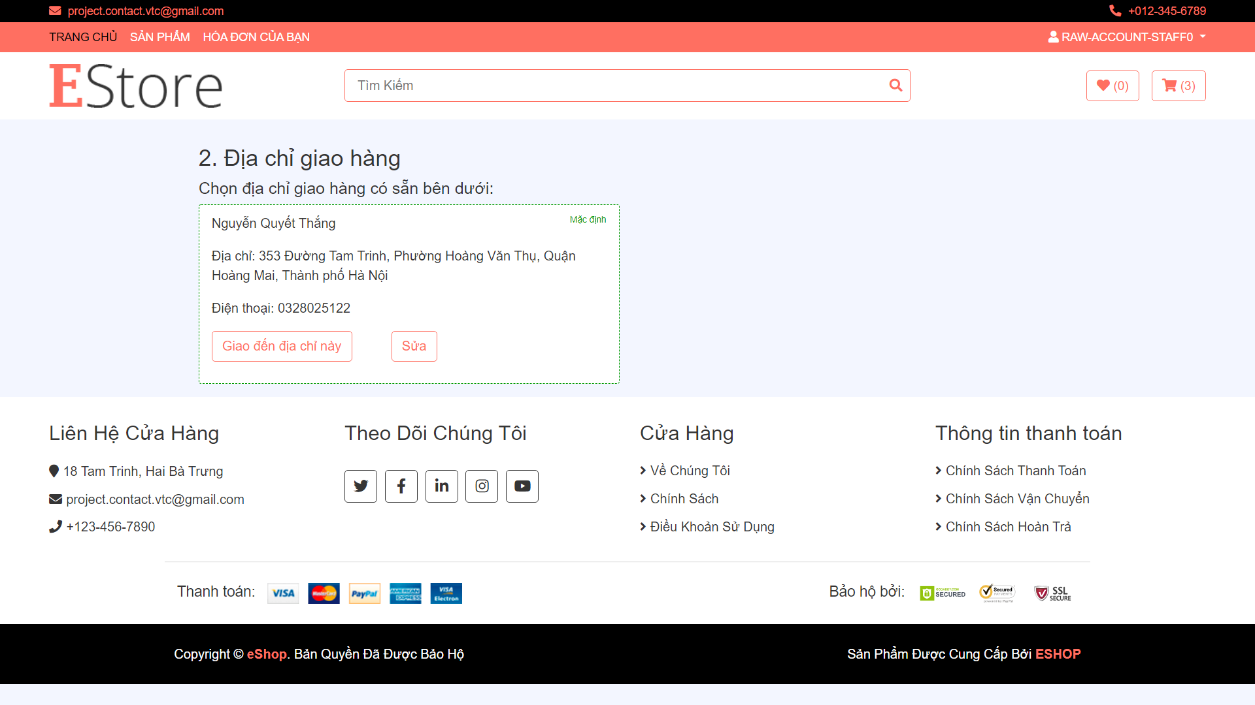

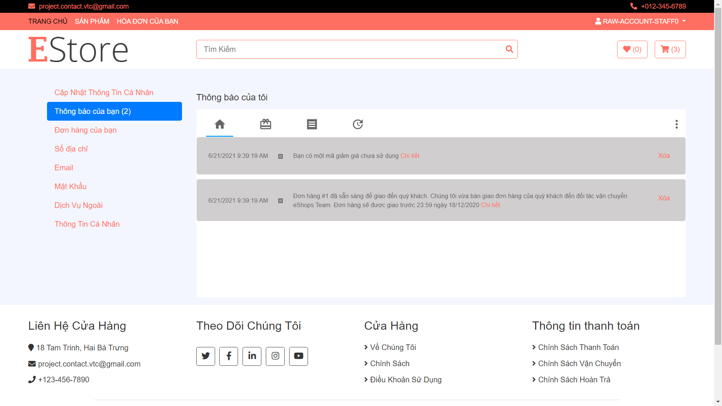

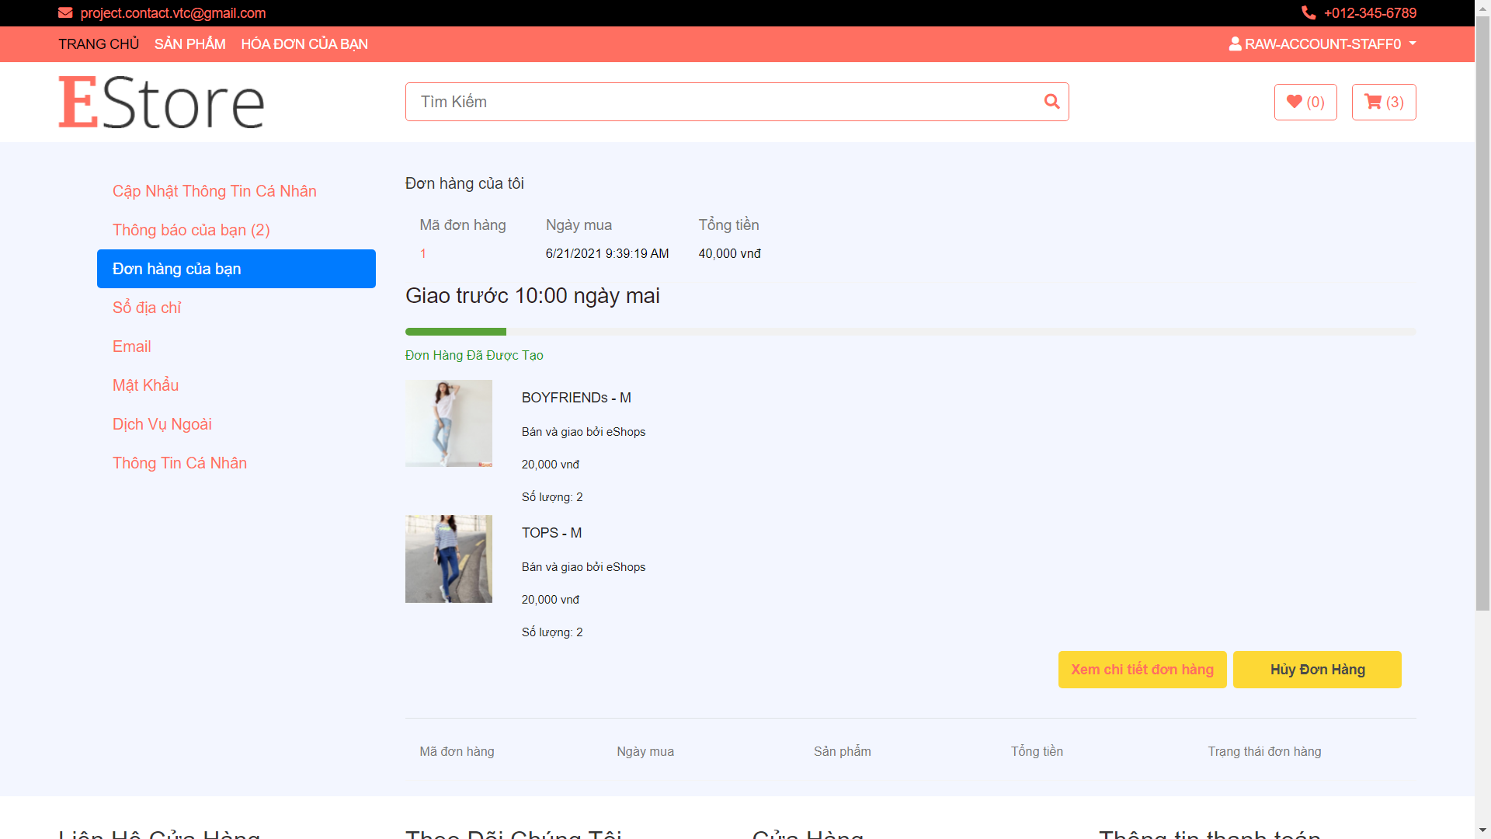

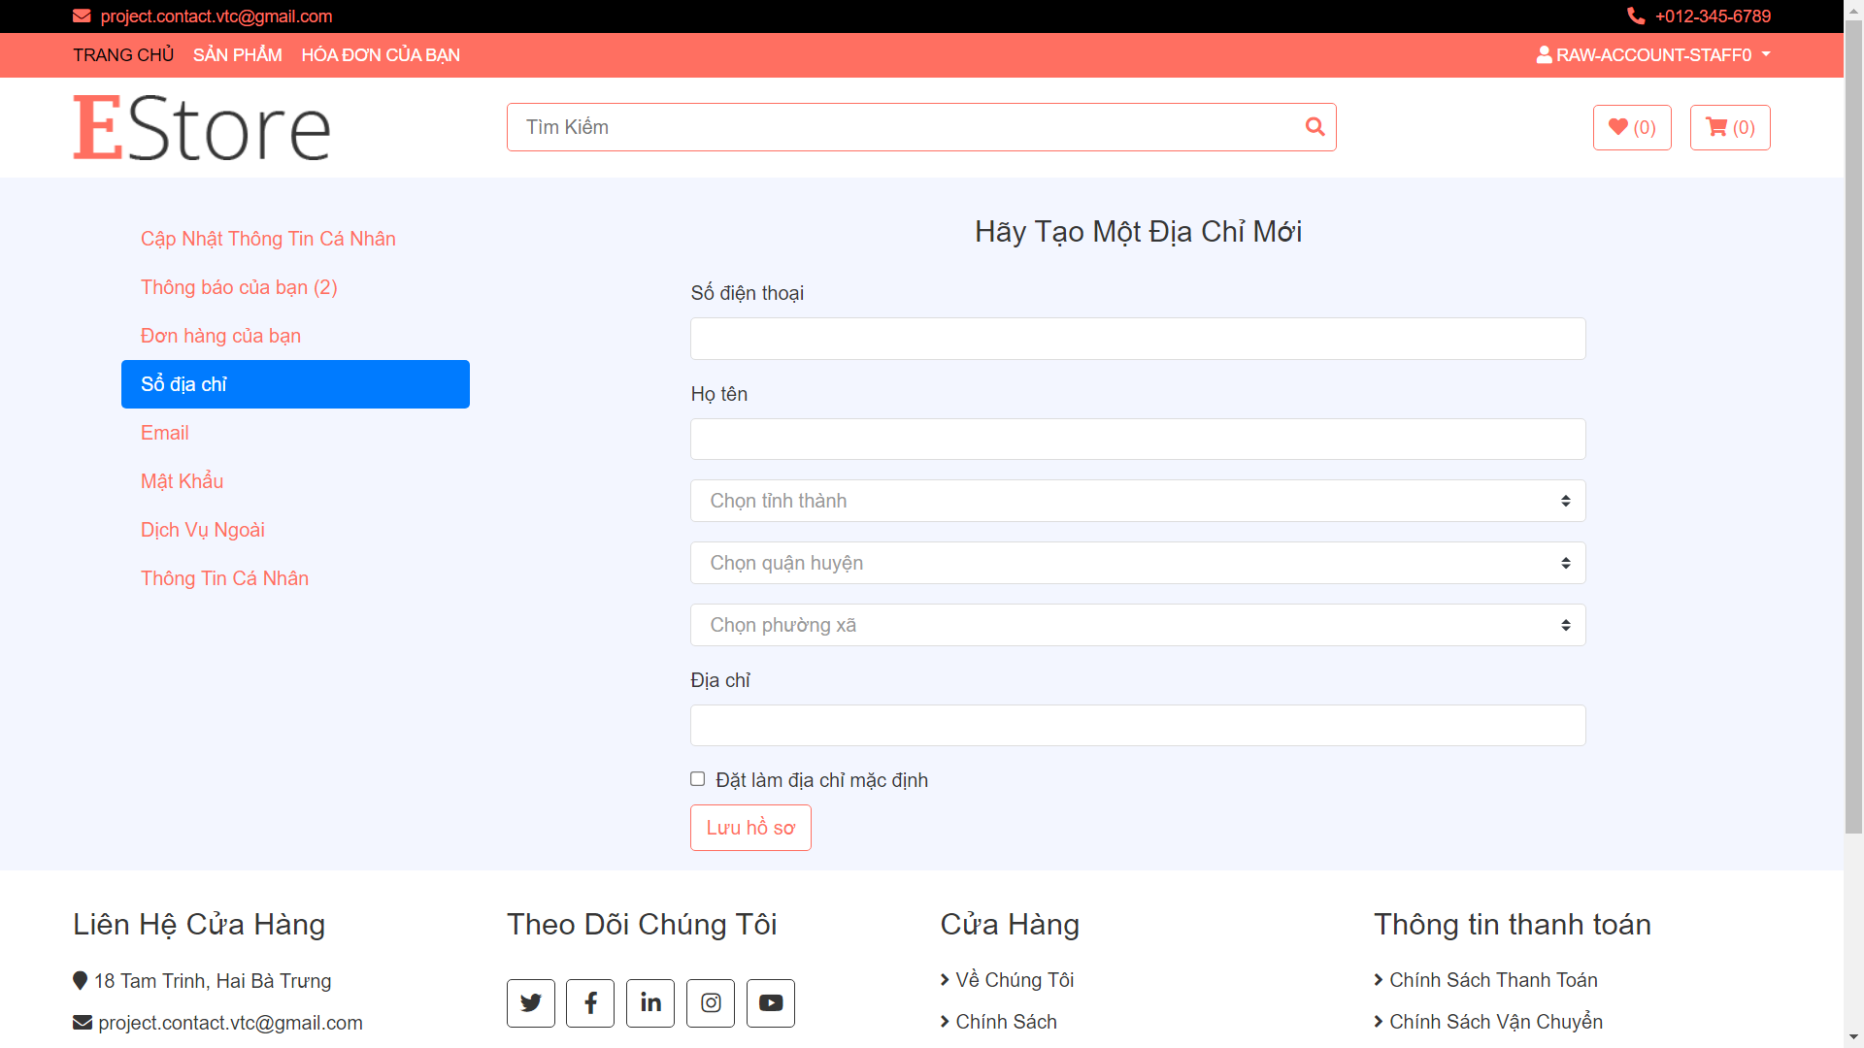

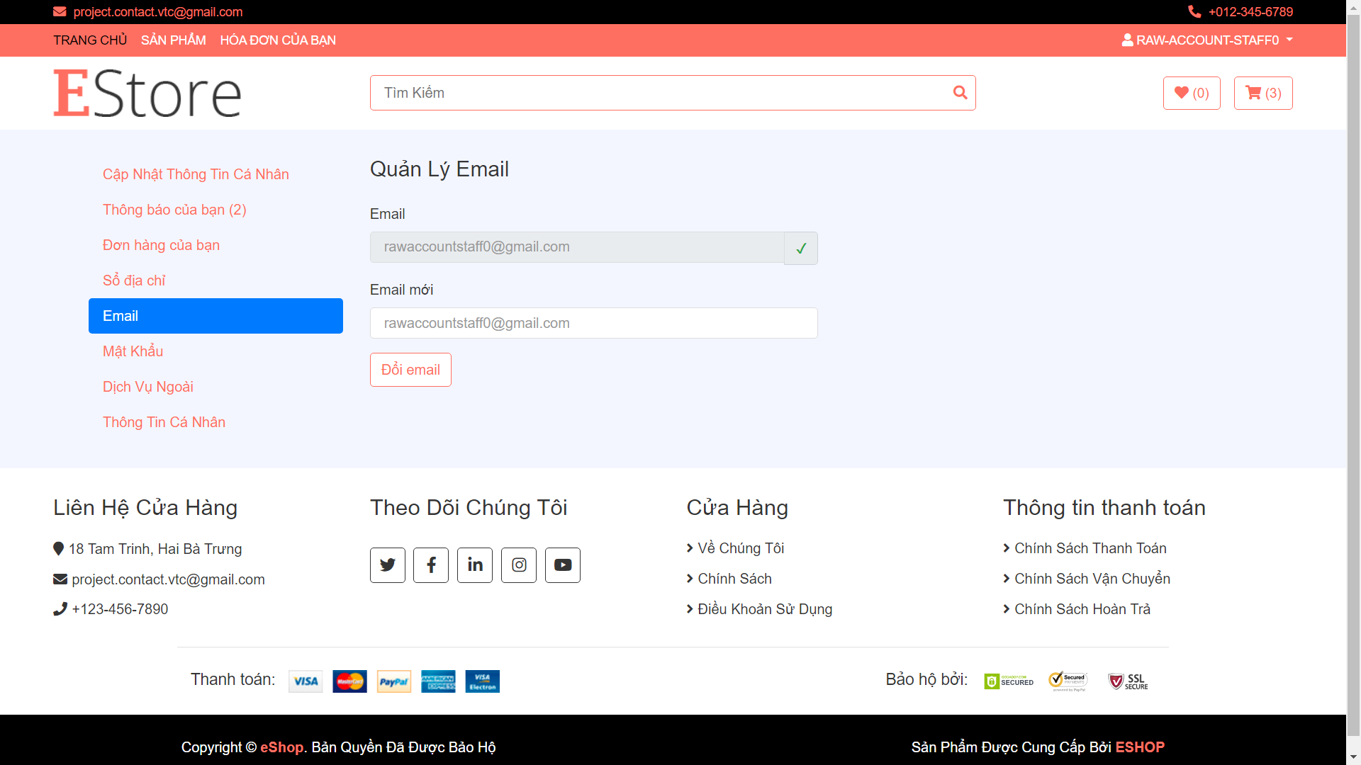

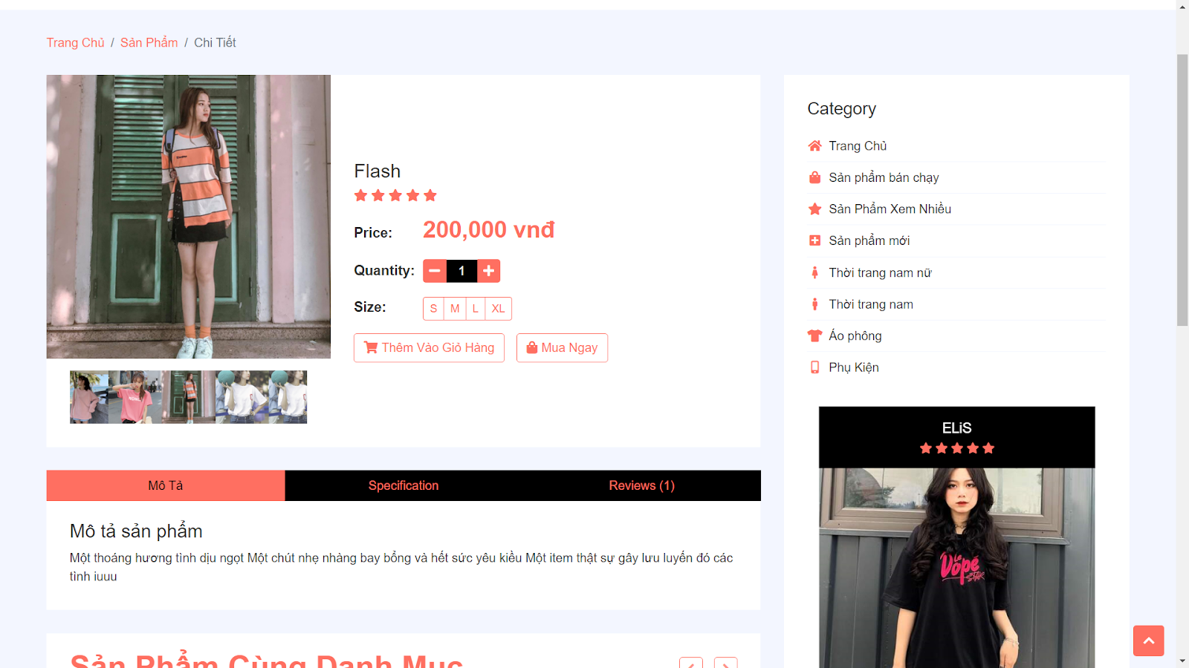

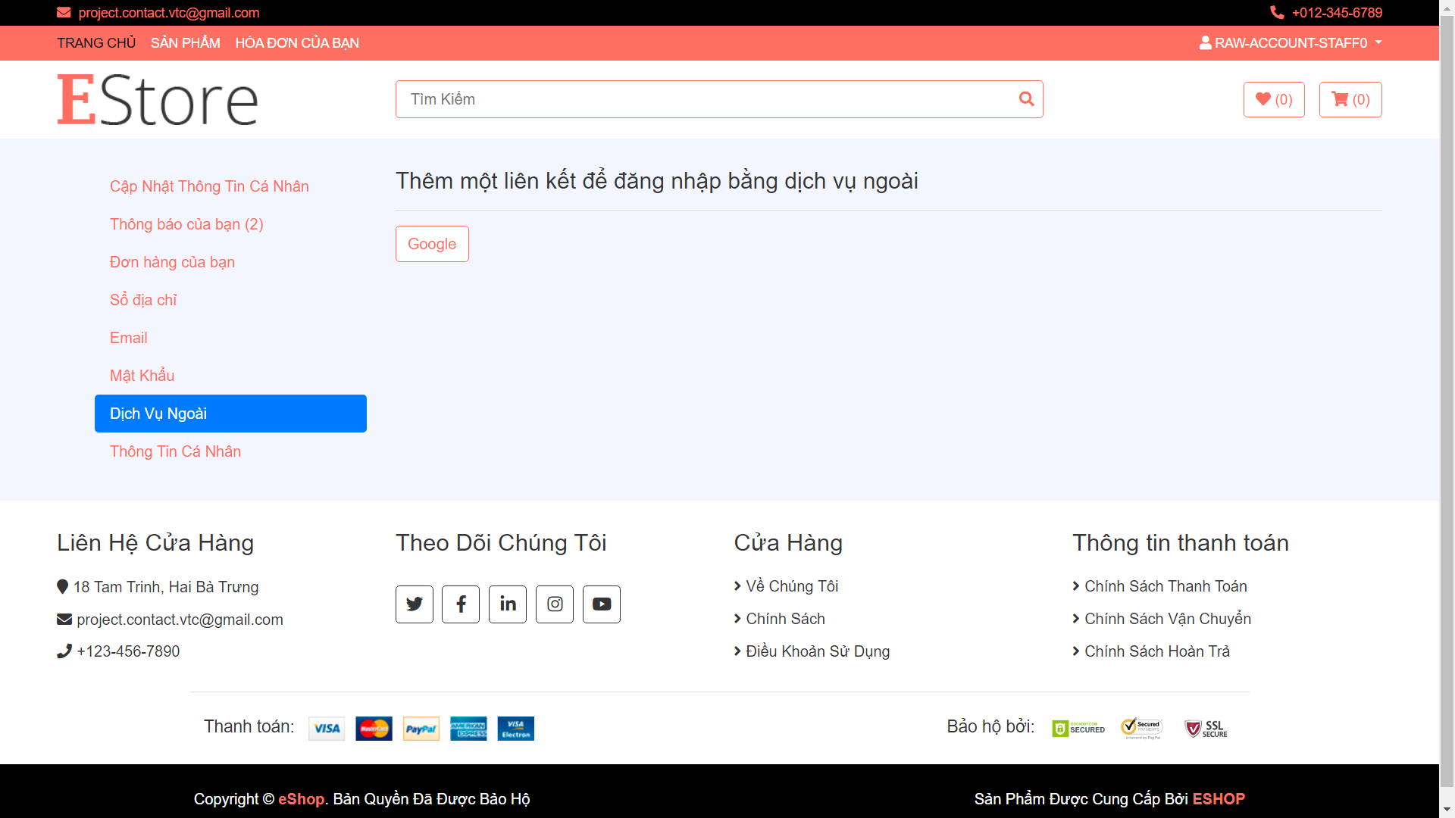

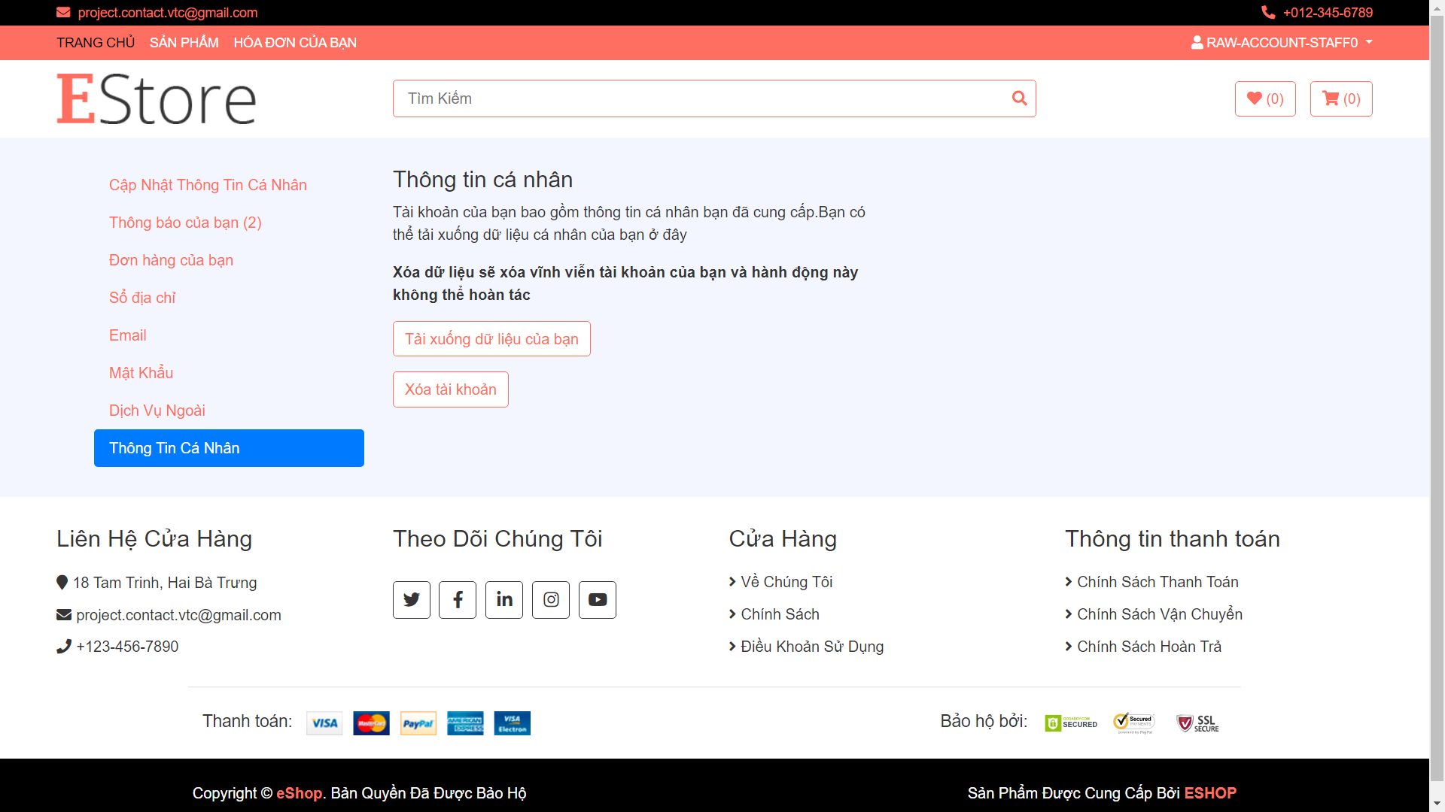

1. Admin Side

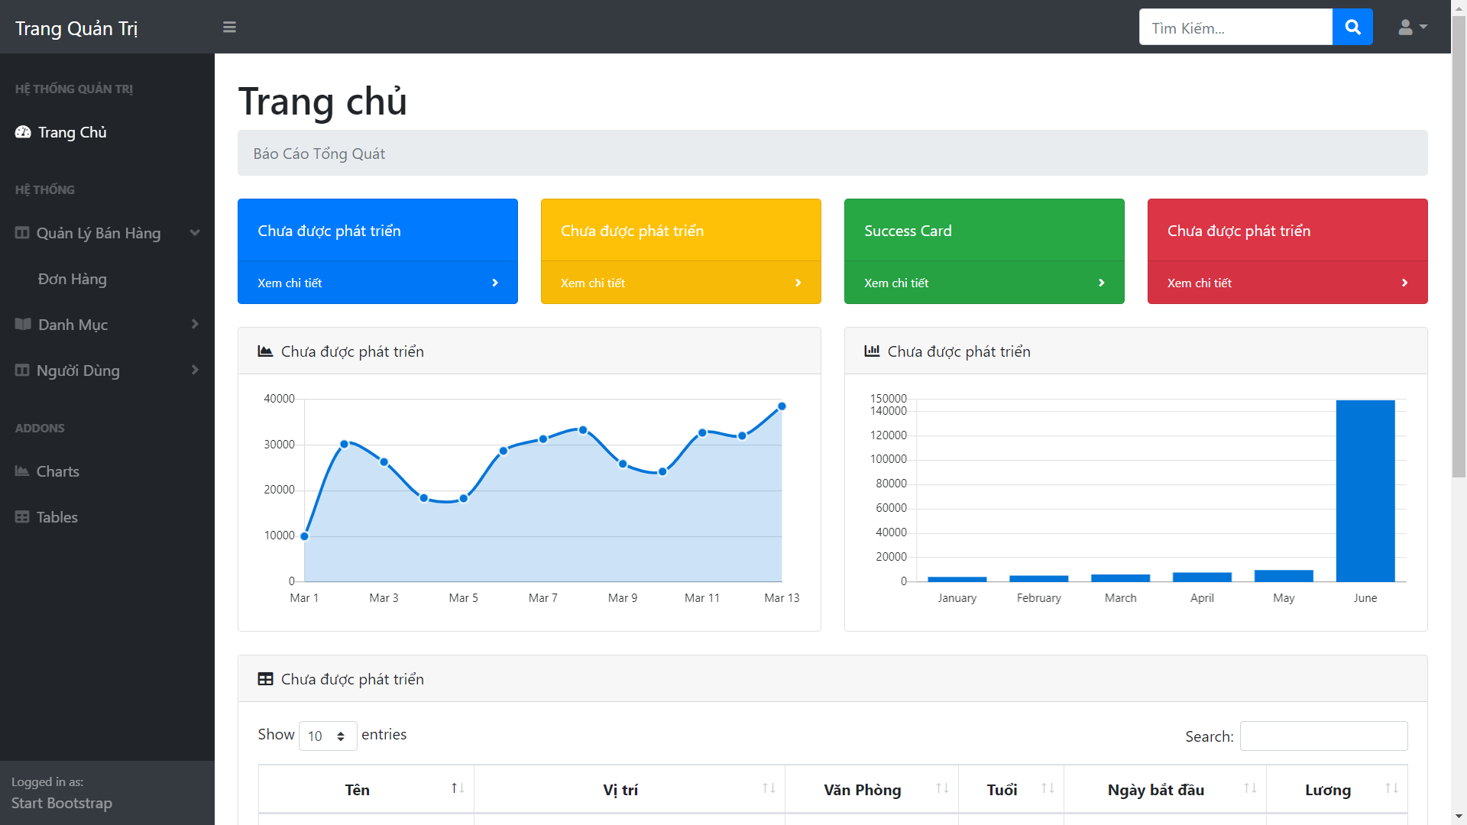

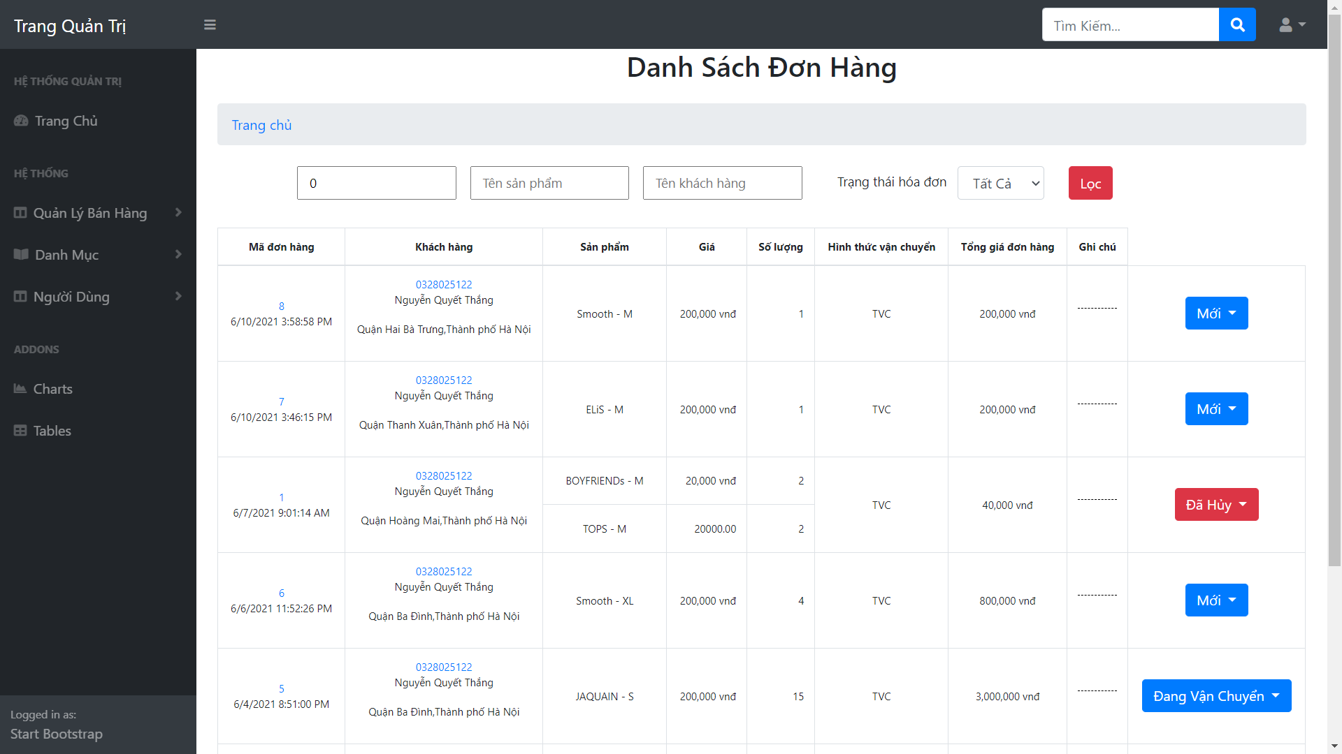

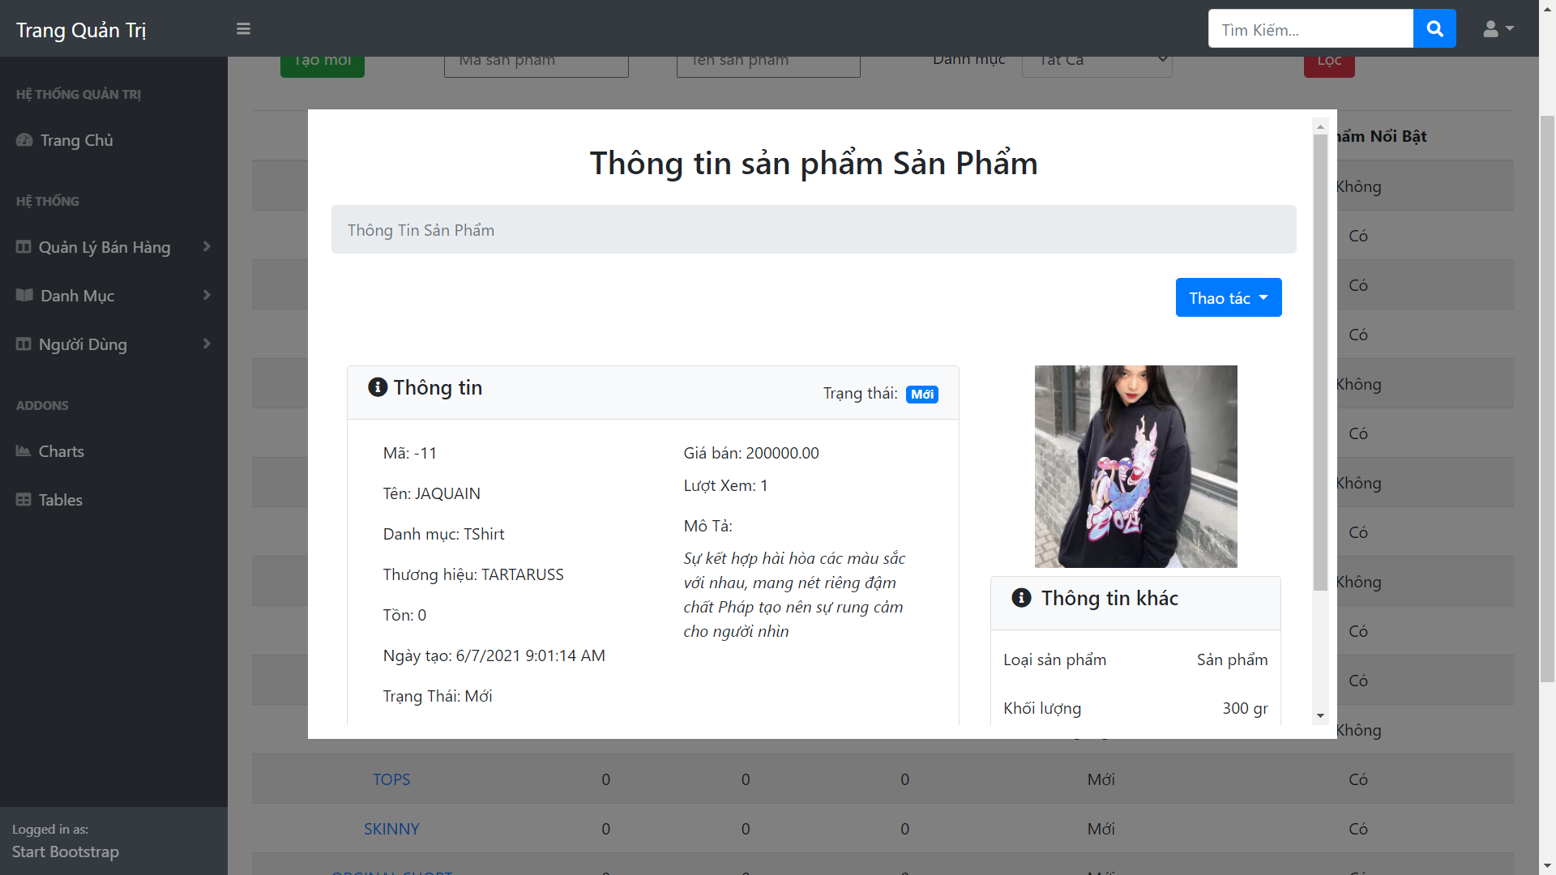

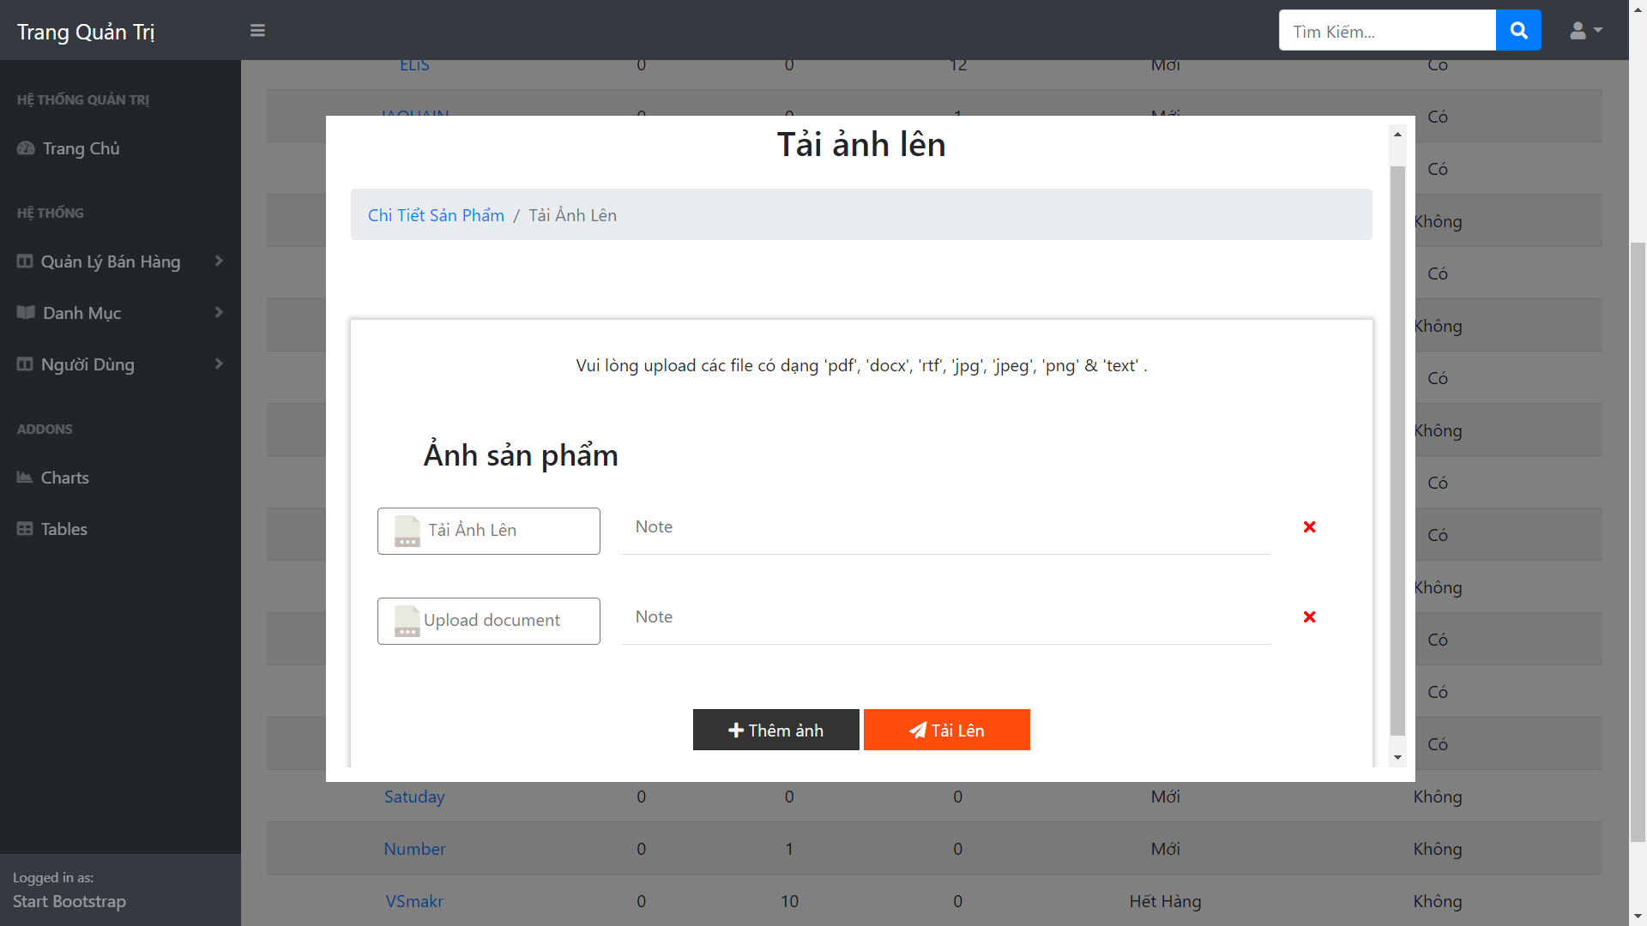

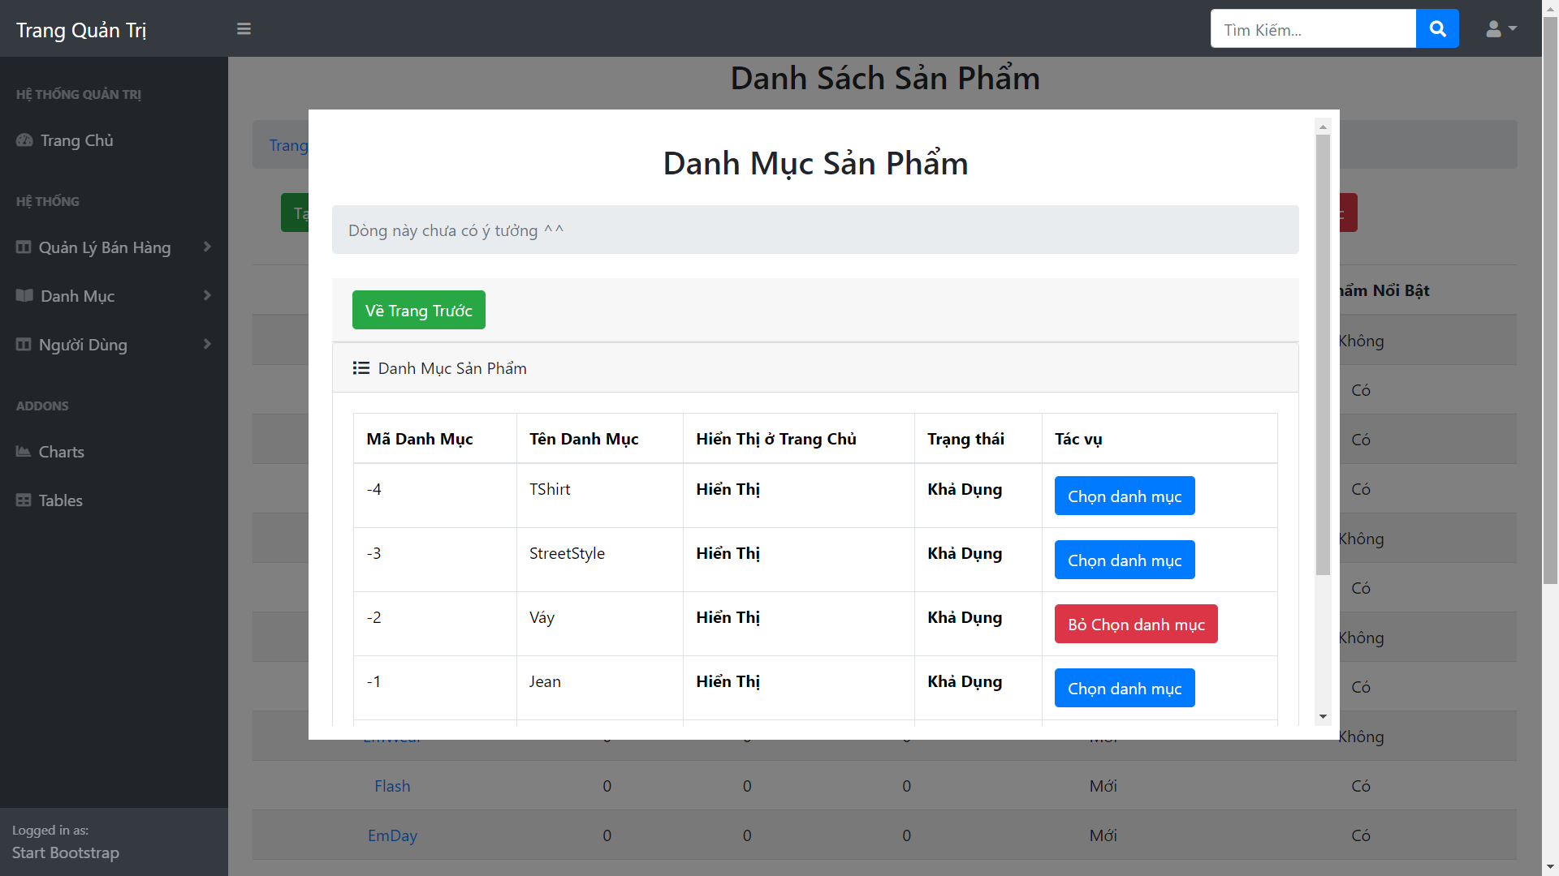

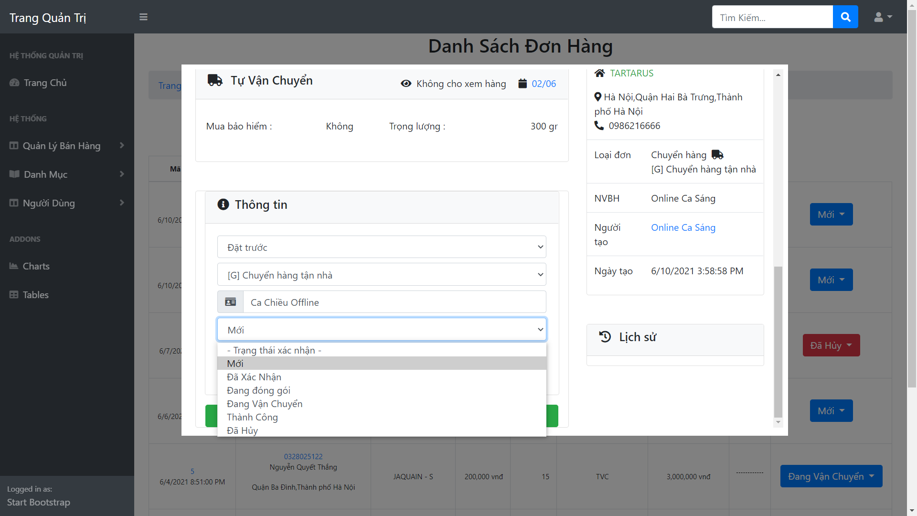

1. Code Design (Class Diagram)

(Class Diagram):

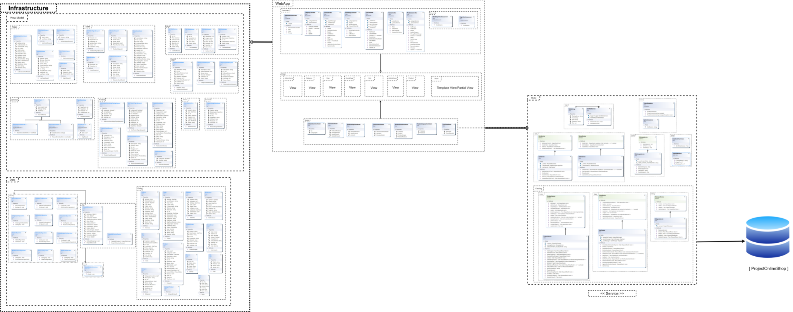

<< See detail in PDF file >>

1. Database Design
   1. Entity Relationship Diagram

<< See in Next Page >>

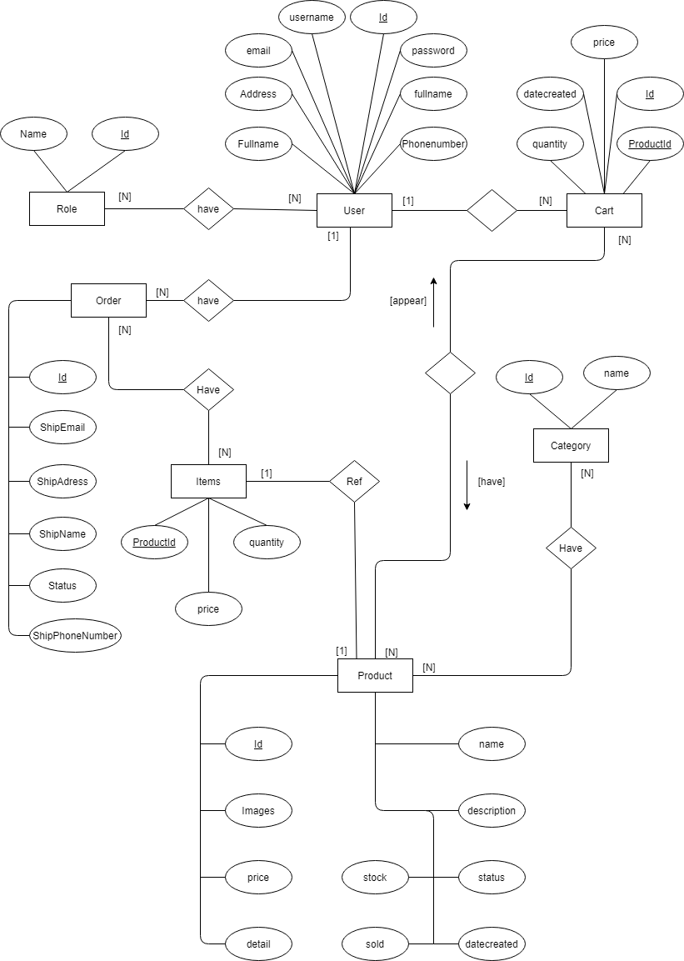

* 1. Database diagram

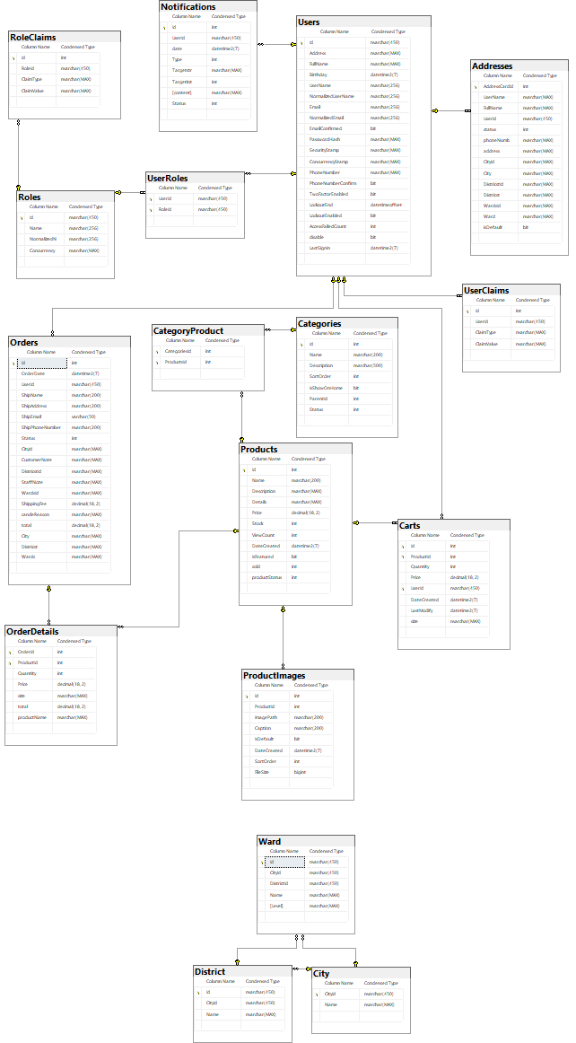

* 1. Database Design Details

| Users | | | |
| --- | --- | --- | --- |
| Column Name | Data Type | Constraints | Description |
| Id | nvarchar(450) | Primary Key, auto_increment |  |
| Address | nvarchar(450) | Nullable | Can be init in other table |
| FullName | nvarchar(MAX) | Nullable |  |
| BirthDay | datetime(7) | NOT NULL |  |
| UserName | nvarchar(256) | NOT NULL | Display on page |
| Email | nvarchar(256) | NOT NULL |  |
| EmailConfirmed | bit | NOT NULL |  |
| PasswordHash | nvarchar(MAX) | Nullable | Can be null if register by  external service |
| SecurityStamp | nvarchar(MAX) | Nullable |  |
| ConcurrencyStamp | nvarchar(MAX) | Nullable |  |
| PhoneNumber | nvarchar(MAX) | Nullable |  |
| PhoneNumberConfirmed | bit | NOT NULL |  |
| TwoFactorEnable | bit | NOT NULL |  |
| LockoutEnd | datetimeoffset(7) | Nullable |  |
| LockoutEnable | bit | NOT NULL |  |
| AccessFailedCount | int | NOT NULL |  |
| disable | bit | NOT NULL |  |
| LastSignIn | datetime(7) | NOT NULL |  |

| UserRoles | | | |
| --- | --- | --- | --- |
| Column Name | Data Type | Constraints | Description |
| UserId | nvarchar(450) | Primary Key, Foreignkey,NOT NULL |  |
| RoleId | nvarchar(450) | Primary Key, Foreignkey ,NOT NULL |  |

| Roles | | | |
| --- | --- | --- | --- |
| Column Name | Data Type | Constraints | Description |
| Id | nvarchar(450) | Primary Key, NOT NULL |  |
| Name | nvarchar(256) | Nullable |  |
| NormalizeName | nvarchar(256) | Nullable |  |
| ConcurrencyStamp | nvarchar(Max) | Nullable |  |

| RoleClaims | | | |
| --- | --- | --- | --- |
| Column Name | Data Type | Constraints | Description |
| Id | int | Primary Key, auto_increment,NOT NULL |  |
| RoleId | nvarchar(450) | Foreignkey ,NOT NULL |  |
| ClaimType | nvarchar(Max) | Nullable |  |
| ClaimValue | nvarchar(Max) | Nullable |  |

| Notifications | | | |
| --- | --- | --- | --- |
| Column Name | Data Type | Constraints | Description |
| Id | int | Primary Key, auto_increment,NOT NULL |  |
| UserId | nvarchar(450) | Foreignkey ,nullable |  |
| date | datetime2(7) | NotNull |  |
| Type | int | NOT NULL |  |
| Targetstr | nvarchar(MAX) | Nullable |  |
| Targetint | int | NotNull |  |
| content | nvarchar(MAX) | nullable |  |
| Status | int | NOT NULL |  |

| Addresses | | | |
| --- | --- | --- | --- |
| Column Name | Data Type | Constraints | Description |
| AddressCardId | int | Primary Key, auto_increment ,NOT NULL |  |
| UserName | nvarchar(MAX) | nullable |  |
| FullName | nvarchar(MAX) | NOT NULL |  |
| UserId | nvarchar(450) | Foreign key,NOT NULL |  |
| status | int | NOT NULL |  |
| phoneNumber | nvarchar(MAX) | NOT NULL |  |
| address | nvarchar(MAX) | NOT NULL |  |
| CityId | nvarchar(MAX) | NOT NULL |  |
| City | nvarchar(MAX) | nullable |  |
| DistrictId | nvarchar(MAX) | NOT NULL |  |
| District | nvarchar(MAX) | nullable |  |
| WardsId | nvarchar(MAX) | NOT NULL |  |
| Ward | nvarchar(MAX) | nullable |  |
| isDefault | bit | NOT NULL |  |

| Categories | | | |
| --- | --- | --- | --- |
| Column Name | Data Type | Constraints | Description |
| Id | int | Primary Key, auto_increment,NOT NULL |  |
| Name | nvarchar(200) | NOT NULL |  |
| Description | nvarchar(500) | nullable |  |
| SortOrder | int | NOT NULL |  |
| IsShowOnHome | bit | NOT NULL |  |
| ParentId | int | nullable |  |
| Status | int | NOT NULL |  |

| Orders | | | |
| --- | --- | --- | --- |
| Column Name | Data Type | Constraints | Description |
| Id | int | Primary Key, auto_increment,NOT NULL |  |
| OrderDate | datetime(7) | NOT NULL |  |
| UserId | nvarchar(450) | foreign key, NOT NULL |  |
| ShipName | nvarchar(200) | NOT NULL |  |
| ShipAddress | nvarchar(200) | NOT NULL |  |
| ShipEmail | varchar(50) | NOT NULL |  |
| ShipPhoneNumber | nvarchar(200) | NOT NULL |  |
| Status | int | NOT NULL |  |
| CityId | nvarchar(MAX) | nullable |  |
| CustomerNote | nvarchar(MAX) | nullable |  |
| DistrictId | nvarchar(MAX) | nullable |  |
| StaffNote | nvarchar(MAX) | nullable |  |
| WardsId | nvarchar(MAX) | nullable |  |
| ShippingFee | decimal(18,2) | NOT NULL |  |
| cancelReason | nvarchar(MAX) | nullable |  |
| total | decimal(18,2) | NOT NULL |  |
| City | nvarchar(MAX) | nullable |  |
| District | nvarchar(MAX) | nullable |  |
| Wards | nvarchar(MAX) | nullable |  |

| CategoryProduct | | | |
| --- | --- | --- | --- |
| Column Name | Data Type | Constraints | Description |
| CategoriesId | int | Primary Key, foreign key,auto_increment,NOT NULL |  |
| ProductsId | int | PK, FK, NOT NULL |  |

| UserClaims | | | |
| --- | --- | --- | --- |
| Column Name | Data Type | Constraints | Description |
| Id | int | Primary Key, auto_increment,NOT NULL |  |
| UserId | nvarchar(450) | FK, NOT NULL |  |
| ClaimType | nvarchar(MAX) | nullable |  |
| ClaimValue | nvarchar(MAX) | nullable |  |

| Carts | | | |
| --- | --- | --- | --- |
| Column Name | Data Type | Constraints | Description |
| Id | int | Primary Key, auto_increment,NOT NULL |  |
| ProductId | int | PK, FK, NOT NULL |  |
| Quantity | int | NOT NULL |  |
| Price | decimal(18,2) | NOT NULL |  |
| UserId | nvarchar(450) | PK, FK, NOT NULL |  |
| DateCreated | datetime(7) | NOT NULL |  |
| LastModify | datetime(7) | NOT NULL |  |
| size | nvarchar(MAX) | nullable |  |

| Products | | | |
| --- | --- | --- | --- |
| Column Name | Data Type | Constraints | Description |
| Id | int | Primary Key, auto_increment,NOT NULL |  |
| Name | nvarchar(200) | NOT NULL |  |
| Description | nvarchar(MAX) | nullable |  |
| Detail | nvarchar(MAx) | nullable |  |
| Price | decimal(18,2) | NOT NULL |  |
| Stock | int | NOT NULL |  |
| ViewCount | int | NOT NULL |  |
| DateCreated | datetime(7) | NOT NULL |  |
| IsFeatured | bit | NOT NULL |  |
| sold | int | NOT NULL |  |
| productStatus | int | NOT NULL |  |

| OrderDetails | | | |
| --- | --- | --- | --- |
| Column Name | Data Type | Constraints | Description |
| OrderId | int | Primary Key, auto_increment,NOT NULL |  |
| ProductId | int | PK,FK,NOT NULL |  |
| Quantity | int | NOT NULL |  |
| Price | decimal(18,2) | NOT NULL |  |
| Size | nvarchar(MAX) | nullable |  |
| total | decimal(18,2) | NOT NULL |  |
| productName | nvarchar(MAX) | NOT NULL |  |

| ProductImages | | | |
| --- | --- | --- | --- |
| Column Name | Data Type | Constraints | Description |
| Id | int | Primary Key, auto_increment,NOT NULL |  |
| ProductId | int | FK, NOT NULL |  |
| ImagePath | nvarchar(200) | NOT NULL |  |
| Caption | nvarchar(200) | nullable |  |
| IsDefault | bit | NOT NULL |  |
| DateCreated | datetime(7) | NOT NULL |  |
| SortOrder | int | NOT NULL |  |
| FileSize | bigint | NOT NULL |  |

| Ward | | | |
| --- | --- | --- | --- |
| Column Name | Data Type | Constraints | Description |
| Id | nvarchar(450) | Primary Key,NOT NULL |  |
| CityId | nvarchar(450) | NOT NULL |  |
| DistrictId | nvarchar(450) | NOT NULL |  |
| Name | nvarchar(MAX) | NOT NULL |  |
| Level | nvarchar(MAX) | NOT NULL |  |

| City | | | |
| --- | --- | --- | --- |
| Column Name | Data Type | Constraints | Description |
| CityId | nvarchar(450) | Primary Key,NOT NULL |  |
| Name | nvarchar(MAX) | NOT NULL |  |

| District | | | |
| --- | --- | --- | --- |
| Column Name | Data Type | Constraints | Description |
| Id | nvarchar(450) | Primary Key,NOT NULL |  |
| CityId | nvarchar(450) | NOT NULL |  |
| Name | nvarchar(MAX) | NOT NULL |  |

# Test

| Test Case Number | 1 |
| --- | --- |
| Test Case Name | Test Connection |
| Test Case Description | access to website to see it working or not |
| Preconditions | has deployed to server |
| Test Case Input | http request to http://103.137.184.108/ |
| Test Case Expected Output | Homepage appear |
| Test Case Steps | Step1: Open Browser  Step2: access to http://103.137.184.108/ |
| Default Value Preserving |  |

# 

| Test Case Number | 2 |
| --- | --- |
| Test Case Name | Testing View returned by HomePageController |
| Test Case Description | Make sure when controller invoker, the ‘Index’ view was called by this |
| Preconditions |  |
| Test Case Input | keyword= null  categoryId= null  id=null  pageIndex = 1  int pageSize = 10 |
| Test Case Expected Output | controller.ViewName = Index |
| Test Case Steps |  |
| Default Value Preserving |  |

# 

| Test Case Number | 3 |
| --- | --- |
| Test Case Name | Testing View returned by HomePageController |
| Test Case Description | Make sure when controller invoker, the ‘ProductDetail’ view was called by this |
| Preconditions |  |
| Test Case Input | id=1 |
| Test Case Expected Output | controller.ViewName = ProductDetail |
| Test Case Steps |  |
| Default Value Preserving |  |

# 

| Test Case Number | 4 |
| --- | --- |
| Test Case Name | Testing View returned by HomePageController |
| Test Case Description | Make sure when controller invoker, the ‘ListProduct’ view was called by this |
| Preconditions |  |
| Test Case Input | listType= null  keyword = null  StartPrice= null  EndPrice= null  categoryId= null  pageIndex = 1  pageSize = 9 |
| Test Case Expected Output | controller.ViewName = ListProduct |
| Test Case Steps |  |
| Default Value Preserving |  |

# 

| Test Case Number | 5 |
| --- | --- |
| Test Case Name | Testing View returned by ProductController |
| Test Case Description | Make sure when controller invoker, the ‘Create’ view was called by this |
| Preconditions |  |
| Test Case Input | categoryId=null |
| Test Case Expected Output | controller.ViewName = Create |
| Test Case Steps |  |
| Default Value Preserving |  |

# 

| Test Case Number | 6 |
| --- | --- |
| Test Case Name | Testing View returned by ProductController |
| Test Case Description | Make sure when controller invoker, the ‘Index’ view was called by this |
| Preconditions |  |
| Test Case Input | keyword= null  categoryId= null  id=null  pageIndex = 1  int pageSize = 10 |
| Test Case Expected Output | controller.ViewName = Index |
| Test Case Steps |  |
| Default Value Preserving |  |

# 

| Test Case Number | 7 |
| --- | --- |
| Test Case Name | Testing View returned by ProductController |
| Test Case Description | Make sure when controller invoker, the ‘Detail’ view was called by this |
| Preconditions |  |
| Test Case Input | id=1 |
| Test Case Expected Output | controller.ViewName =Detail |
| Test Case Steps |  |
| Default Value Preserving |  |

# 

| Test Case Number | 8 |
| --- | --- |
| Test Case Name | Testing View returned by ProductController |
| Test Case Description | Make sure when controller invoker, the ‘Update’ view was called by this |
| Preconditions |  |
| Test Case Input | id=1 |
| Test Case Expected Output | controller.ViewName = Update |
| Test Case Steps |  |
| Default Value Preserving |  |

# 

| Test Case Number | 9 |
| --- | --- |
| Test Case Name | Testing View returned by ProductController |
| Test Case Description | Make sure when controller invoker, the ‘AssignCategory’ view was called by this |
| Preconditions |  |
| Test Case Input | id=1 |
| Test Case Expected Output | controller.ViewName = AssignCategory |
| Test Case Steps |  |
| Default Value Preserving |  |

# 

| Test Case Number | 10 |
| --- | --- |
| Test Case Name | Testing View returned by ProductController |
| Test Case Description | Make sure when controller invoker, the ‘ManageImage’ view was called by this |
| Preconditions |  |
| Test Case Input | id=1 |
| Test Case Expected Output | controller.ViewName = ManageImage |
| Test Case Steps |  |
| Default Value Preserving |  |

# 

| Test Case Number | 11 |
| --- | --- |
| Test Case Name | Testing View returned by ProductController |
| Test Case Description | Make sure when controller invoker, the ‘GetListImage’ view was called by this |
| Preconditions |  |
| Test Case Input | productId=1 |
| Test Case Expected Output | controller.ViewName = GetListImage |
| Test Case Steps |  |
| Default Value Preserving |  |

# 

# Task Assign (to each team member)

| Group 03 | eCommerce eShop Project | | | | | |
| --- | --- | --- | --- | --- | --- | --- |
| No | Task name | Description | Start Date | End Date | Member | Self assessment |
| 1 | Planning | Recruit member, choose topics , plan, technology selection | 11/03/2021 | 15/03/2021 | Thang | 2/5 |
| 2 | Design UI/UX | Ui design and Ux design | 15/03 | 20/03 | Thang,Huan | 4/5 |
| 3 | Use case Design | System functional design | 15/3 | 30/3 | Thang | 3/5 |
| 4 | Use case Description | Write document about descriptions of use case | 15/3 | 30/03 | Thang, Huan | 3/5 |
| 5 | Use Case Activity Diagram | Draw activity of each use case | 15/03 | 15/04 | Thang | 3/5 |
| 6 | Use Case Sequence Diagram | Draw flow function | 05/04 | 20/04 | Thang | 3/5 |
| 7 | Creating Project | First step to built project code | 1/04 | 10/04 | Thang | 3/5 |
| 8 | Code | Raw project | 10/04 | 19/04 | Thang | 3/5 |
| 9 | Code | Clean Up project | 20/4 | 20/4 | Thang |  |
| 10 | Code | Create simple User Function | 22/4 | 2/5 | Thang |  |
| 11 | Code | Create Admin Product | 2/5 | 2/5 | Thang |  |
| 12 | Code | Category Service | 11/5 | 12/5 | Thang |  |
| 13 | Code | Cart Function | 14/05 | 22/05 | Thang |  |
| 14 | Code | Customer HomePage | 24/05 | 30/5 | Thang |  |
| 15 | Code | Customer Address function | 1/6 | 7/6 | Thang |  |
| 16 | Code | Customer Create Order | 8/6 | 12/6 | Thang |  |
| 17 | Code | Finish Local Project | 12/6 | 18/6 | Thang |  |
| 18 | Code | Host and Deploy | 19/6 | 21/06 | Thang |  |
| 19 | Finish Report | Draw Deployment Diagram | 22/06 | 22/06 | Thang |  |
| 20 | Finish Report | Create Sile | 21/06 | 22/06 | Thang |  |
| 21 | Finish Report | Draw Poster | 22/06 | 22/06 | Thang |  |
| 22 | Pre Report | participate in trial protection session | 24/06 | 24/06 | Thang |  |
| 23 | Update web | fix error , optimized web , rewrite report | 24/06 |  | Thang |  |

# Installation Instructions

Deployment Diagram

* Overall Diagram about working system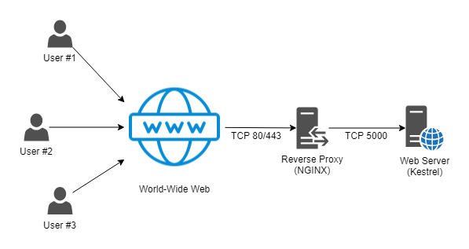
* Deployment Diagram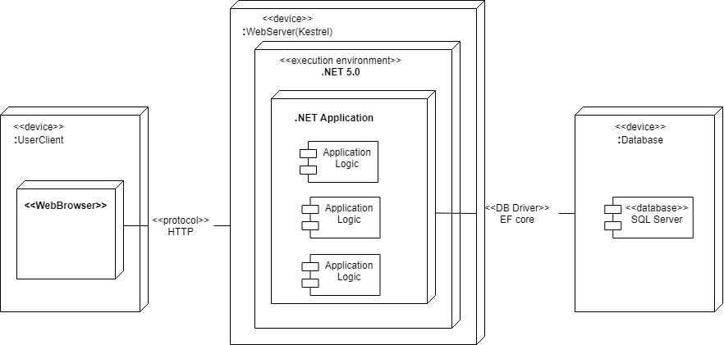
* Deployment Diagram for connect to Cloud database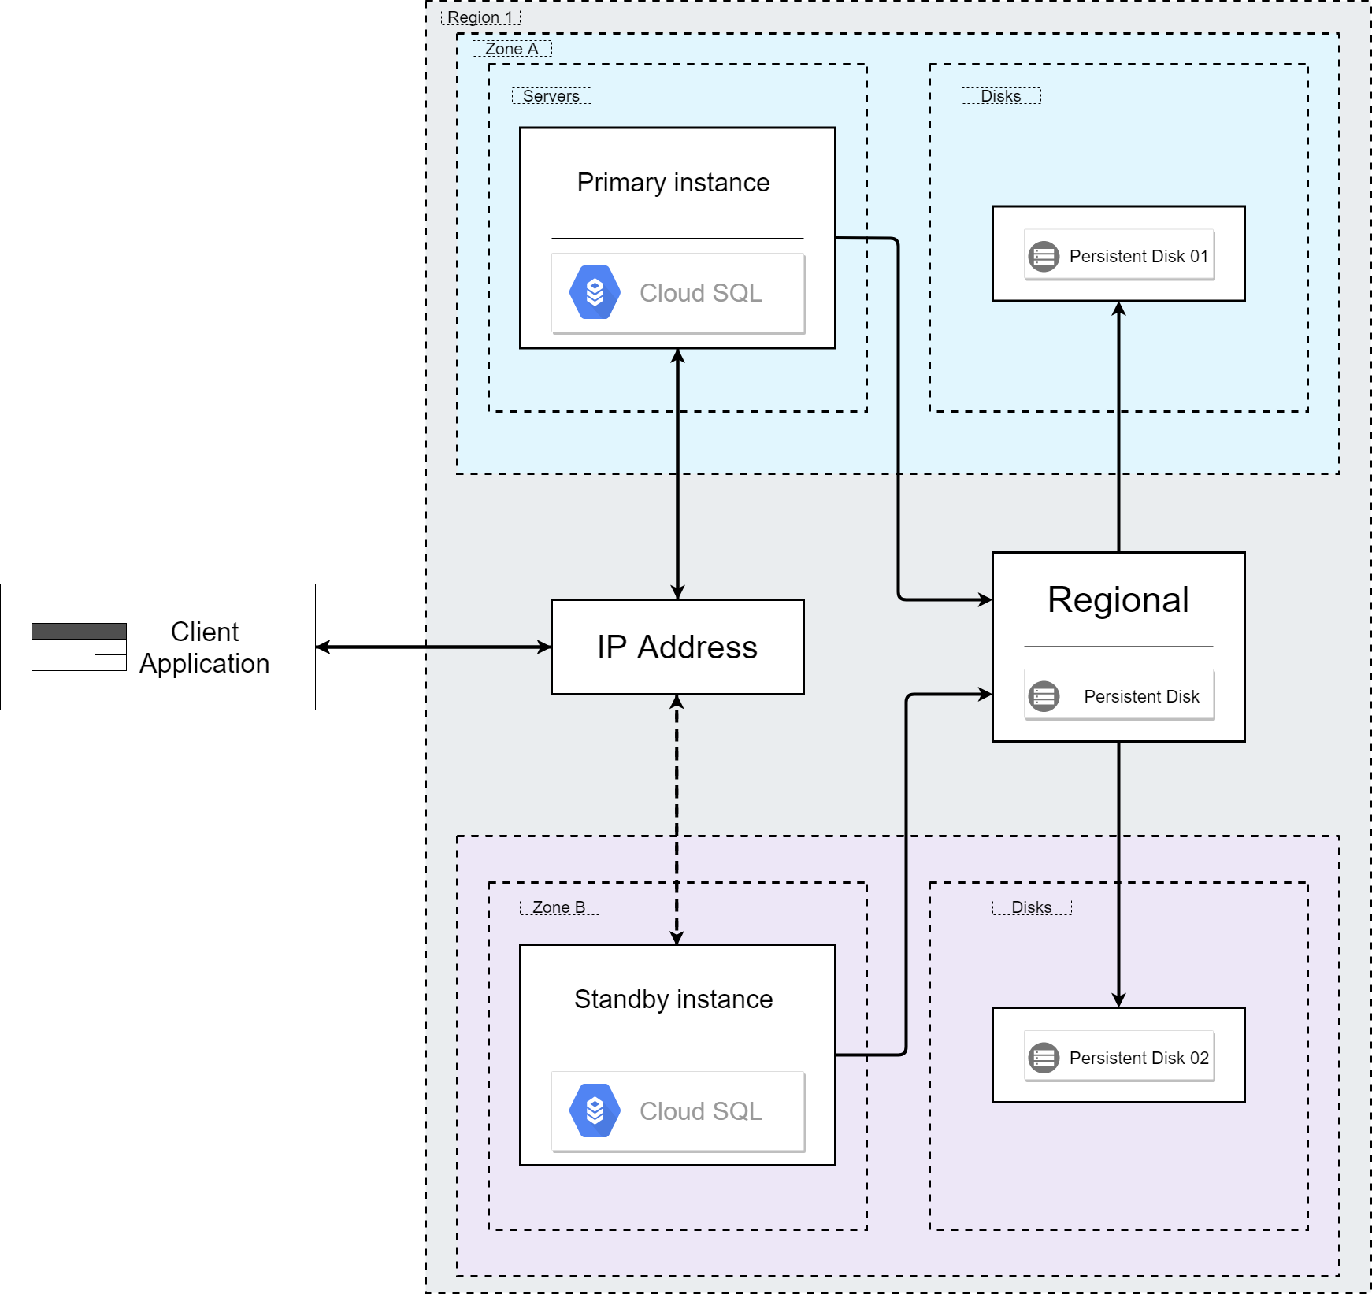

1. Installation steps
   * Database Install

Step 1: Prepare source code

( you can clone code from here : <https://github.com/thangdev-vlth/OnlineShopProject.git> )

Step 2: Connect to vps (provided by <https://hostingviet.vn> ) via ssh

Step 3: Clone code from github

Step 4: Install .NET in server

Step 5: Install Nginx in server

Step 6: Install Git

Step 7:Install SQL Server

Step 8: Publish asp app

Step 9: Create service for app

Step 10: running server

* + Server install
    1. .NET
    2. nginx
    3. SQL Server
    4. Git
  + Use
    1. Access to <http://103.137.184.108:5001/>
    2. Default Account
       1. Customer :
          1. User : [rawaccountcustomer0@gmail.com](mailto:rawaccountcustomer0@gmail.com)
          2. Password : 123456
       2. Staff :
          1. User : [rawaccountstaff0@gmail.com](mailto:rawaccountstaff0@gmail.com)
          2. Password : 123456
  + Application install
    1. Brower (chrome , microsoft edge,...)
    2. Internet Connected

# Appendix

Terms and abbreviations

References

* Template : <https://tiki.vn>
* Template : <https://htmlcodex.com>
* Management Experience : <https://nhanh.vn>
* Host and deploy : <https://sinhnx.dev>
* Template : <https://startbootstrap.com/template/sb-admin>
* Host and deploy : <https://docs.microsoft.com/en-us/aspnet/core/host-and-deploy/linux-nginx?view=aspnetcore-5.0>
* Cloud Database : <https://clients.cloudclusters.io/>
* Solution for problem: <https://stackoverflow.com/>
* Solution for problem:<https://tedu.com.vn/>
* Source control version <https://github.com/>
* Application function solution :<https://xuanthulab.net/>

Some other issues

* Result:
  + Host and Deploy real website to internet
* limitation:
  + Diversity in system function
  + Project focus
  + Practicality
  + Ability of extension
  + Finishing time
* Experiences :
  + Experience in working with C# language
  + Experience in working with .Net
  + Experience in working with GitHub
  + Experience in working with writing document
  + Experience in working with server side
* Techniques :
  + .Net 5.0
  + Ubuntu 18.04
  + Nginx
  + Cloud Database
* Considering when implementing a project
  + Server memory doesn’t enough to install db
  + Sequence diagram design

# 